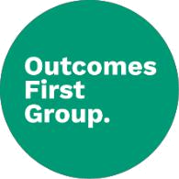




SEND EHCP Policy

Policy Number | 1.0
Review Date | September 2025
Owner | Carla Adams-McCoy – Headteacher

Document History

Version | Comments/amendments | Name | Date
1.0 | First Version | Carla Adams-McCoy | September 2024

Introduction

At Brinksway School, we are dedicated to creating an environment where every pupil, regardless of their background or individual needs, can thrive. This forms the basis of our vision statement: Together we inspire each other to thrive; doing our best in everything we do. This vision drives our commitment to providing a tailored, person-centred approach to each student’s education.
For all our students, an Education, Health and Care Plan (EHCP) is a crucial part of ensuring they receive the right support to succeed. Our EHCP policy outlines the process through which we work collaboratively with families, external professionals, and the local authority to design and implement an effective and individualised support plan for each pupil.

In line with the Children and Families Act 2014, this policy also ensures that we are providing the highest standards of care and support. We are committed to regularly reviewing and updating the EHCPs, through liaison with the associated Local Authorities, to ensure they remain relevant and effective in promoting positive outcomes for our students.

Background

Most pupils attending Brinksway School have a diagnosis of Autism Spectrum Condition (ASC) and many have other co-occurring needs to varying degrees; these may include additional learning difficulties, speech and language difficulties, sensory impairments and/or physical difficulties.

In all cases, the individual needs of our learners have, for various reasons, proved too complex to have been successfully catered for within mainstream provision, or there has not been capacity within maintained special schools in the area. As a result, most of our students travel to school from outside Stockport.

At Brinksway School, we are proud of our specialist expertise in autism. The school makes every effort to identify and assess pupils’ special educational needs, as well as provide effective support and a suitably differentiated curriculum, to ensure they progress and succeed to the best of their ability.

Aims:

- To identify all pupils with special educational needs, to assess the extent of their difficulties and to plan appropriate strategies and programmes to meet their needs.
- To ensure that all teachers and teaching assistants are aware of pupils' difficulties and are provided with strategies and individual programmes to use with those identified pupils.
- To monitor and review the progress across the curriculum of pupils with special educational needs, thereby ensuring that those pupils achieve their potential by being able to function fully and confidently in the classroom.
- To involve, as fully as practicable, the pupil and their parents/carers in decision making and monitoring processes.

Clinical involvement

At Brinksway school, we are very fortunate to have access to an extensive in-house clinical team. This comprises of an Occupational Therapist, Speech and Language Therapist, as well as support from a Psychotherapist and Psychologist, all of whom are overseen by Julia Hunter (Clinical Lead and SaLT).

As a result of the clinical team being based onsite, staff have an in-depth knowledge of all pupils that attend Brinksway. This is invaluable and ensures they can respond to new/emerging needs as they occur. The referral process for staff is clear, and referrals are reviewed by the clinical team on a weekly basis.

The clinical team triage the levels of need within school regularly, facilitated by a termly ‘Pyramid Review’. When a pupil starts at Brinksway, they are reviewed within the first half term, and it is termly thereafter. Clinical input is reviewed, and pupils are either identified as requiring ‘all’, ‘group’ or ‘individual’ provision. The clinical team use parent/teacher views, classroom observations and EHCPs, to inform these decisions.

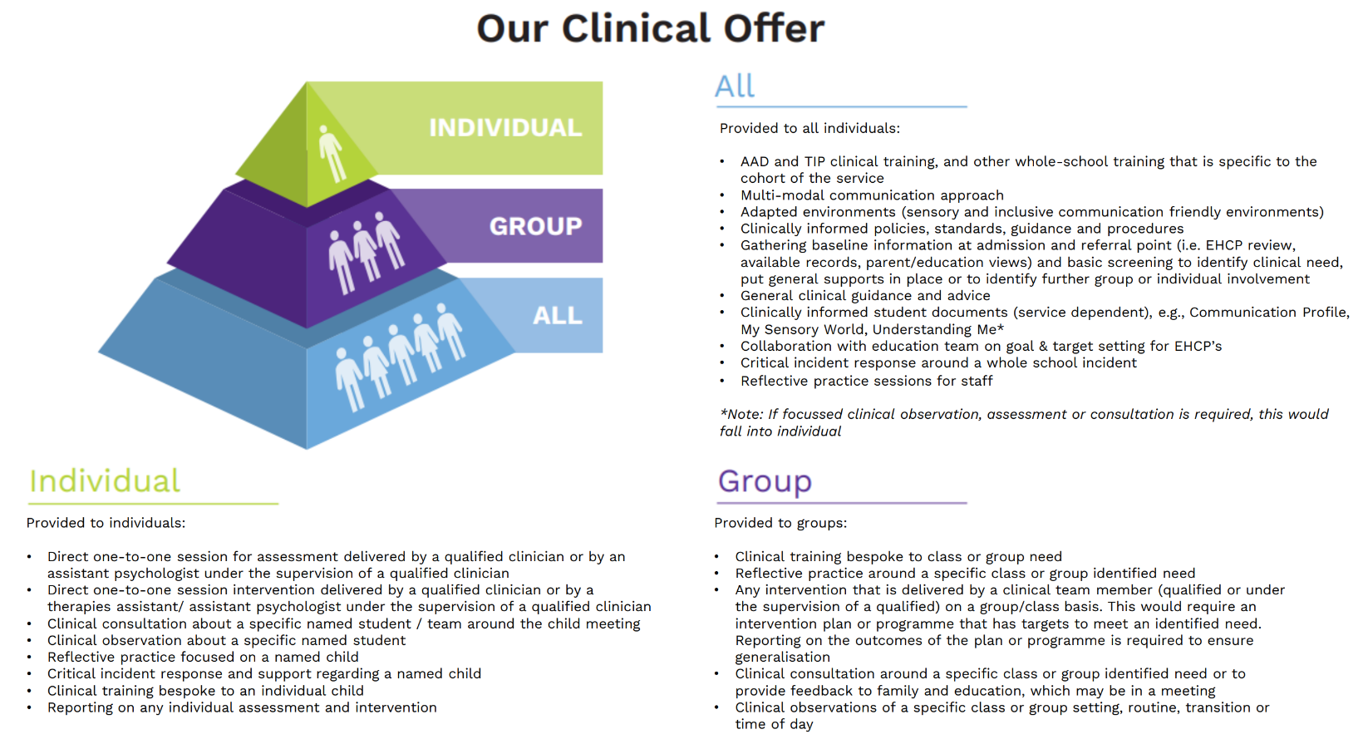

As part of the support package within school, multi-disciplinary meetings are held on a half termly basis for each class, which the OT, SALT & SENCO attend. This ensures that individual needs can be met more effectively as support for pupils is co-ordinated.

Important clinical documents:

- SaLT – ‘Ask Accept Develop’ (AAD) profiles (everyone)
- OT – ‘My Sensory World’ profile (everyone)
- Psychotherapy – ‘Understanding Me’ document (only pupils receiving 1:1 sessions)

Clinical input is dependent on written consent from families being provided and is unable to begin until this has been received.

Where changes to EHCPs are recommended by the clinical team, this is communicated in the report they contribute to the annual review process.

Baseline Assessments

Each new pupil has a baseline assessment in Literacy and Numeracy within half term of starting at Brinksway School.

These baseline assessments inform planning for teaching and learning, curriculum objectives, target setting and exam access arrangements.

Curriculum

At Brinksway, our curriculum is split into 3 pathways to accommodate the diverse learning needs of our pupils:

- Pyramid: pre-formal learners
- Viaduct: semi-formal learners
- Mersey: formal learners

As all our pupils have an Education Health Care Plan, their learning is adapted to meet their individual needs and tailored to their personal learning goals (PLGs), which are updated termly.

Every pupil has a ‘curriculum rationale’ to state why they are working within the identified pathway. As a school, we recognise that a pupils’ needs may change during their time at Brinksway, so there is flexibility to move between pathways if this is deemed appropriate.

For more information on areas of learning within the different pathways, please refer to Brinksway’s Curriculum Policy.

Personal Learning Goals (PLGs)

Every pupil has a set of personal learning goals (PLGs) that are updated at the start of each term. They will have a minimum of one target (maximum of 2) for each area of learning within their ECHP:

- Communication and Interaction
- Cognition and Learning
- Social, Emotional and Mental Health
- Sensory and Physical
- Independence & Community

These are assessed 3 times within the term using the EDSM criteria (emerging, developing, secure and mastered). They will have a baseline, midway and final assessment, captured using Evidence for Learning. The final assessment is then generated into a pdf report and shared with parents.

As well as PLGs, pupils are also supported by clinical documents (see above), an individual risk assessment, pathway rationale, and a positive support plan (if required).

The positive support plan details:

- Behaviours that may be displayed at different levels of arousal.

- Possible causes/triggers for these behaviours.

- De-escalation strategies and how to proactively support the pupil.

- How to respond if/when these behaviours do occur.

- How to support the individual in the recovery stage.

It also details any CPI (Crisis Prevention Institute) holds that may be required as a last resort to ensure the safety of the individual. This will always be communicated with parents and agreed before the positive support plan is finalised.

EHC Plan monitoring

The SENCo (Penny Silverwood) liaises with the relevant authorities in relation to EHCP amendments and EHC transition planning and represents the educational requirements of each young person as relevant to their needs.

Recommendations will then be made to the respective LA as to whether any changes need to be made, either to the EHCP or to the funding arrangements for the child (in accordance with SEN Code of Practice 2014).

Annual Reviews

A statutory review of each pupil’s progress towards meeting the objectives written in their EHCP is held at least once a year. An Annual Review report is produced by the class teacher, reporting on progress towards EHCP outcomes, as well as the curriculum areas of the pathway they are following.

Two weeks prior to the meeting, this report is circulated to parents/carers, the LA and other agencies (including social workers), via email.

One week prior to the meeting, class staff will support the pupil to record their own views, using our ‘pupil voice’ proforma (see below). Depending on the needs/preferences of the pupil, they can either draw, write or type into the boxes. If their fine motor skills are a barrier to this task, a member of staff may scribe for them. For our earliest learners (following the pre-formal pathway), it may be appropriate that a staff member captures the pupil’s views by inserting photos and comments into this document.
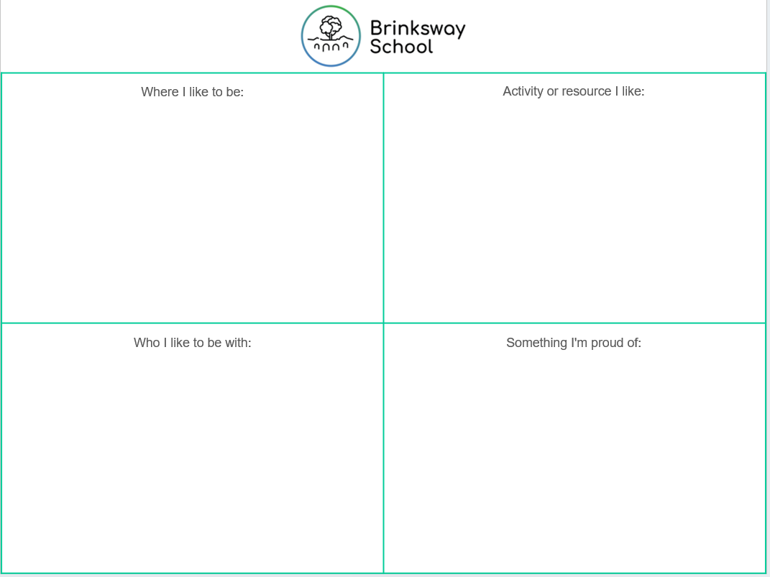

Parents/carers, the class teacher, SENCo, a member from the clinical team attend the annual reviews. A Local Authority representative is insisted upon if school are struggling to meet the individual’s needs. Alternatively, recommendations are sent to the LA following the review.

