
Wr

Anti-Bullying Policy

Brinksway School
Written: September 2024
Review Date: September 2025
September 2026

Contents

Statement of general principles 3

Our aims are 3

Introduction 3

Our obligations 4

What is bullying? 5

Emotional and physical symptoms linked to Bullying 5

Who bullies? 6

Who are the victims? 6

Our school policy and practice 7

Positive steps to prevent bullying 8

Bullying outside of school premises 10

Monitoring 11

Evaluation, the policy will be deemed to be a success if: 12

Conclusion 12

Staff Protection (see Equal Opportunities policy and Whistleblowing Policy) 12

Harassment 13

This policy has been drafted in consultation with the latest recommendations from the DfE Behaviour and Discipline in Schools January 2016, DfE Preventing and Tackling Bullying July 2017, DfE Supporting Children and young people who are bullied: advice for schools March 2014, The Independent Schools Standards 2015 and the Equality Act 2010.

Statement of general principles

- Everyone has the right to feel safe in school.

- We should be polite to each other at all times.

- Everyone has to take responsibility for their own actions;

- Everyone should be given respect.

- Brinksway is committed to the principle that targeting, harassment and bullying constitutes unacceptable behaviour and that reports of targeting and bullying will be taken seriously.

Our aims are:

- To provide a secure environment in which pupils and staff can report incidents confidently

- To show all pupils and staff that targeting, harassment and bullying is taken seriously

- To enable staff to respond calmly and confidently to targeting, harassment and bullying incidents

- To reassure pupils and staff that the school will protect and support all parties whilst the issues are resolved

- To provide long term and positive programmes of personal development where it is required

Introduction

In this policy we are not concerned with those deeper personal, social, emotional or psychological issues that underlie and often precipitate bullying behaviour. What we are intent upon is a clear explanation of a set of attitudes and a related framework for intervention that will allow us to manage the problem of targeting, harassment and bullying in an efficient and effective manner. These guidelines are intended to help staff to develop a shared understanding of the problems involved in identifying, containing, reporting and intervening when we face children’s targeting, harassment or bullying behaviour. We need a team approach and a common sense of purpose. We must have a generally understood framework for action and procedures that are clear and workable. Our hope is that the following policy will provide structures appropriate to these tasks.

This is an extremely important area. We work with children who exhibit emotional and behavioural difficulties. They have often been hurt themselves. They often seek to retaliate against people and things. Containing these complex and persistent aggressions within the peer group is one of our primary professional tasks. Any failure to do so will release sub-cultural peer group reactions, which may have serious consequences for a number of our pupils. We need to be aware of these peer group dynamics. We have to monitor the peer group very carefully for signs of intimidation and bullying. We must then take considered and decisive action. We should always remember, that bullying research carried out in recent years has clearly demonstrated that the vast majority of pupils attending Brinksway School, come to us usually with a history of bullying as either victims or bullies.


Our obligations

In developing a whole school policy towards bullying we start with the knowledge that this behaviour, in all its forms, will occur from time to time in the school. This is true of every school. It is an on -going feature of working with children and a particular feature of our working with ASC pupils, who in the vast majority of cases, come to us with a history of either being bullied or bullying others. It will occur again. The frequency and intensity of this problem will depend largely upon the ethos of the school, the intervention strategies we employ and our capacity to contain and manage the interpersonal behaviour of our pupils. We also recognise that there are times when adults can also bully and be bullied. The government document https://www.gov.uk/workplace-bullying-and-harassment explains that workplace bullying and harassment is described as behaviour that makes someone feel intimidated or offended. Harassment is unlawful under the Equality Act 2010.

Examples of bullying or harassing behaviour include:
- spreading malicious rumours

- unfair treatment

- picking on or regularly undermining someone

- denying someone’s training or promotion opportunities

Bullying and harassment can happen:

- face-to-face

- by letter

- by email

- by phone

It explains the law around this, what employees should do and the obligations of employers.

The prevention and recognition of bullying implies a vigilant and consistent approach by all stakeholders who all carry a very heavy duty of care for every pupil placed with us and our colleagues in the workplace. Many are particularly vulnerable given the nature of their previous experiences. Our policy on bullying is one important aspect of our professional obligation to create a caring and protective environment for our pupils and staff.

What is bullying?

There are many definitions of bullying. At Brinksway School, we see it as inappropriate behaviour from an individual or group of individuals towards another individual that is deliberate, may be repeated over time, and is hard for the individual to defend against. It is essentially an abuse of power by a stronger person) against a weaker one. The advantage in strength may be either physical or verbal; it might be real or imagined; and can be expressed individually or collectively with others.

Examples of bullying in our context would include:

- Hitting and punching
- Kicking

- Spitting
- Spoiling someone else’s belongings
- Calling names
- Excluding or deliberately isolating a person
- Giving nasty looks

- Making racist, homophobic or sexist remarks

- Making comments about another person’s family o Picking on a weakness

- Spreading rumours
- Preventing somebody from joining a game
- Not talking to someone or getting other people not to talk to another
- Putting pressure on another person – for example, to run errands and do jobs, to give up possessions, to bring things from home.

- Forcing a person to engage in sexualized activity or behaviour

- Unkind or threatening internet or mobile phone text messages or images (Cyber bullying)
- The use of social media(Cyber bullying)

Emotional and physical symptoms linked to Bullying

It is often hard to spot people who are experiencing targeting, harassment and bullying. By its nature, it is an insidious activity that usually goes on out of sight of staff. The victim is often reluctant to come forward because they feel that ‘telling’ might only make matters worse for themselves and make the situation worse. The following symptoms might be an indication that a person is being bullied:
Emotional
- Lost confidence

- Loss of self-esteem
o Irritability
o Aggression

o Panic attacks
o Depression

o Suicidal thoughts

Physical | Sleeplessness
o | Sleeplessness
o | Nausea
o | Shaking
o | Heart racing
o | Laziness
o | Skin complaints
o | Stomach aches
o | Migraines and headaches

Who bullies?

This policy has used the following books, publication and websites as key points of reference:

Elliot M (1991) Bullying: A Practical Guide to Coping for Schools, La Fontaine J (1991)

Bullying: A Child’s View, Pearce J (1989) Fighting, Teasing and Bullying, Smith P K and Thompson D (1991) Practical Approaches to Bullying, DfES Publications (2002) Bullying: don’t suffer in silence, DCSF (2007) Safe to learn: embedding anti-bullying work in schools, Equality Act 2010, DfE Preventing and Tackling Bullying July 2017, DfE Supporting Children and young people who are bullied: advice for schools 2014
It is clear from the literature that a significant number of our pupils experience home circumstances which foster the development of bullying attitudes – for example: -

- Poor parental role models
- Aggressive male figures
- Poor relationship with mother
- Inconsistent punishment by parents
- Physically and verbally aggressive adults

“Bullies are associated with general anti-social rule breaking behaviour in school and in the community”

“They are often aggressive towards parents, teachers and siblings.”

“Contrary to popular belief, bullying victims don’t always differ much from other children”

(Quotes from Tattum and Herbert, 1990)

Who are the victims?

Anyone can be targeted, harassed or bullied. There are, however, certain risk factors that will make the experience of bullying more likely. For pupils, they include:

- Lacking close friends in school o Being shy

- Coming from an over protective family environment
- Being from a different ethnic group to the majority

- Being different in some obvious respect from the majority
- Having particular educational, social or medical needs

- Being a Looked After Child
- Being a carer
- Being a ‘proactive victim’ – a child who behaves inappropriately with others, barging in on games or being a nuisance

None of these characteristics can excuse allowing a child to be targeting, harassed or bullied.

It is safe to assume that we are always going to have to manage a proportion of children (and staff) in our school who are potential (and actual) bullies and victims.

Our school policy and practice

The following guidelines provide a framework for containing and changing attitudes towards bullying. These have been compiled with reference to advice from the DfES anti-bullying guidance pack, Bullying: don’t suffer in silence (2002) and DCSF Safe to Learn (2007), Equality Act 2010, DfE Preventing and Tackling Bullying July 2017 and DfE Supporting Children and young people who are bullied: advice for schools March 2014 . They are aimed at creating an ethos that will not tolerate the oppression of one person by another. These guidelines aim to establish a whole-school policy and contain both long and short-term strategies that involve the school organisation and curriculum.

- All pupils, parents and staff must recognise that any form of targeting, harassment and bullying is completely unacceptable in our school. This message will be made explicit when a child and his family/carers first come for interview; it will be stated very clearly in the pupil and staff handbook and will be reiterated regularly in school assemblies and tutor meetings.

- No member of staff or pupil must ever ignore a person being bullied or in distress as a result of being bullied. No tales of bullying must ever be discounted. They must be recorded in the Bullying Log Book, referred to the FAPS team and thoroughly investigated. Seeing and doing nothing is professionally indefensible. It implies support for the aggressor and is the worst response an adult can offer. It offers no help to the victim and is an act of collusion with the bully.

- Every case of bullying must be followed up immediately.

(One study found 25% of teachers interviewed felt it was sometimes helpful to ignore bullying problems. This is not a view we subscribe to under any circumstances.)

- The member of staff dealing with the incident must make an initial judgement as to its severity. More serious cases, and those involving adults must be referred to a member of the Senior Leadership Team or SWIFT (Pastoral Team).

- Any adult witnessing must write an incident report (use school recording system) stating:

- When?
- Where?
- What happened?
- Who was involved?
- How they dealt with it.
- Action to be taken.

SLT must be informed of this, once the incident has been deemed as bullying then the incident must also be recorded in the Bullying Log Book. Incidences will also be recorded on Sleuth.

- Victims need to be given support. They will need re-assurance that the matter will be dealt with discreetly and sensitively and that they will suffer no further occurrences of repercussions from disclosure. They are entitled to positive action: stopping the targeting, harassment and bullying immediately without implying that they are the cause of what has been done to them. It must be a priority to ensure that those who are victims of bullying are given structured support through education staff, therapy and parents/carers. This should be accomplished through the existing handover/daily home contact and referral systems already in place. As members of staff, we must ensure that this happens.

- Adults dealing with an incident must not be physically or verbally aggressive towards the aggressor. We must never bully the bully. It gives creditability, if we react in this way, to the very behaviour we seek to eliminate. We do, however, act very firmly and purposefully in our interventions with those who are producing anti-social hostile behaviour towards others.

- The member of staff must make the unacceptable nature of the behaviour and its consequences clear to the bully. The range of sanctions available for pupils for minor incidents are outlined in the school behaviour policy. For staff, they are outlined in the code of conduct. Something must be done, even if it is only discussing the incident with the victim at the end of the school day. The victim must see that any form of targeting, harassment or bullying are taken seriously.

More severe incidents will be dealt with by senior staff. For pupils, he parents, the Local Education Authority, and the social worker (if applicable), will be informed in writing by the Headteacher.

- A fixed term exclusion (or staff suspension) will be considered when there are repeated or serious incidences of bullying. The Head of Service or Head of School will make this decision, but it will only be used under very special circumstances (See Guidelines on Exclusion).

- The school will not hesitate to exclude pupils or suspend staff whom they believe jeopardize the safety of other children or continually threaten their right to safety. Again, this will be used very infrequently and only after very careful consideration by staff and full consultation with parents and referring agencies.

- When a formal complaint of bullying is received either from a pupil, staff member or a parent and subsequently dealt with through the school’s anti bullying procedures that is not the end of the matter. At the conclusion of the process the member of staff who has dealt with the complaint will use the school’s Standard Satisfaction Survey for Parents and staff to ensure that the parent is happy with the way the school’s systems for dealing with bullying have worked and been effective. In the case of a child making a complaint of bullying, the Key Worker will carry out individual work with that pupil to ensure that the pupil’s complaints have been effectively dealt with and the child concerned has suffered no significant long-term harm.

Positive steps to prevent bullying

- Always be aware of the school’s physical environment. It is difficult to specify where bullying is likely to occur in buildings and grounds such as ours, but by visiting ‘quiet’ locations frequently and by knowing where all the children you are responsible for are playing/occupied (and with whom), difficulties are less likely to occur. Staff should familiarize themselves with the area risk assessments that deal with location based bullying and ensure that the control measures detailed for each area of the school estate are followed.

- Good supervision is a key requirement for controlling targeting, harassment and bullying behaviour and ensuring the safety and security of pupils. All colleagues will follow school policies with regard to supervision both during activities and especially during unstructured ‘free time’. The school’s Area Risk Assessments provide further information.

- All staff must be vigilant for the early signs of distress in pupils.

For example: Isolation

A desire to remain with adults all the time

Erratic attendance.

Although these behaviours may be symptomatic of other problems, they may indicate that bullying is taking place.

- Likewise everybody must be observant for any other indications that a child is being targeted.

For example: Personal equipment, belongings or clothes being ‘lent’ or going missing Money received from home going quickly

Clothes being damaged

Bruising/injuries

- Children must not ‘buy off’ the bully with sweets or other ‘presents’ and they must never give in to demands for money. They are strongly recommended to talk to a member of staff, a pupil they trust or any name in their pupils’ handbook. (See child protection procedures and the pupils’ handbook.)

- Children are not encouraged to hit back. We are a ‘communicating’ school and never advocate aggression as a means of solving problems. It may well also be contrary to the child’s nature. We seek to resolve conflict creatively and constructively.

- Non-violent behaviour must be recognised and celebrated. The means of rewarding it are detailed in the school’s behaviour and discipline policy.

- The victims of bullies need their self-esteem raised through activities designed to improve their social skills. They need support from all the involved adults, both at school and at home, to counter feelings of inferiority and guilt. Suggestions for suitable activities and strategies are the responsibility of all staff and will be reflected in individual support work, individual education plans and tutorial work.

- Any sexist or racist comments must be challenged. Once again, a failure to act implies concurrence. We have a very determined equal opportunities policy and the ethos we are trying to maintain is well documented.

- Bullying as a subject will be addressed in the following ways:

- Through assemblies and tutorials bullying can be addressed directly. The school curriculum addresses the issue of bullying in various ways. Citizenship addresses the issue directly and attempts to make students aware of the issue and its implication for all concerned. It also attempts to equip students with the knowledge and skills necessary to deal with the various forms of bullying, which may occur. In Religious Education the emphasis is on care and respect for one another and an acceptance and acknowledgement of the different qualities each student brings to the school. In English opportunities which arise from the study of literature are used to examine bullying and its consequences. Science, Art, Music and Physical Education directly encourage teamwork and sharing, as do most other subjects on the curriculum. Cyber bullying is addressed in ICT lessons and stand-alone lessons around the issues relating to bullying take place during the year particularly during Anti Bullying Week every November.

- Brinksway School works together with the Safer schools partnership to gain support with issues of bullying and Non-criminal bad behaviour that occurs on or off site

- Anti-Bullying Information leaflet made available to Staff, Parents, Carers and Pupils (Appendix 1)
- Ancillary/domestic staff must be encouraged to report any incidents of bullying that they see. This coincides with their role in the school’s policy on behaviour and discipline.
It is discussed regularly in their meetings with supervisory staff.

Bullying outside of school premises

Teachers have the power to discipline pupils for misbehaving outside the school premises “to such an extent as is reasonable”. This can relate to any bullying incidents occurring anywhere off the school premises, such as on school or public transport, outside the local shops, or in a town or village centre. This behaviour may also be deemed as being non-criminal bad behaviour.

Where bullying/non-criminal bad behaviour outside school is reported to school staff, it should be investigated and acted on. The Head of School should also consider whether it is appropriate to notify the police or anti-social behaviour coordinator in their local authority of the action taken against a pupil. If the misbehaviour could be criminal or poses a serious threat to a member of the public, the police should always be informed.

- In all cases of misbehaviour or bullying the teacher can only discipline the pupil on school premises or elsewhere when the pupil is under the lawful control of the staff member

.Monitoring

The monitoring of bullying (using Sleuth) should have regard to information about incidents of bullying and how they were resolved, both immediately and over the longer term. Monitoring procedures can be used for two purposes:

- To enable schools to follow up and record progress.

Individual incidents which, on the surface may seem to be an isolated occurrence, may be part of a much larger pattern of bullying behaviour. Monitoring can be helpful in identifying such patterns.

- To establish whether or not our anti-bullying practices are really being effective.

Records of incidents can show whether bullying is becoming less frequent or changing in nature. The results can provide insights into ways in which practice needs changing or adapting.

The monitoring of incidents will be carried out by the Pastoral Team (SWIFT) to highlight any patterns and information passed to SLT.

Evaluation, the policy will be deemed to be a success if:

- Staff are more vigilant and responsive to bullying.

- Fewer people report being bullied or that they are bullying.

- More pupils say that they would not join in bullying someone else.

- More pupils would tell a member of staff if they were being bullied.

Conclusion

In conclusion the following points are worth re-iterating:

- Targeting, harassment and Bullying does not stop of its own accord. It must be stopped by all staff acting with a common purpose, through a commonly understood set of procedures. There is no prefect system for eradicating this problem. It is ever-present and needs to be dealt with firmly and constructively as part of the therapeutic ethos of the school.

- Small children who are bullied tend to become larger children who seek to bully others. We need to break this pattern. We need healthy traditions which can only emerge from children feeling safe within our environment. How children treat others depends very much on how they themselves are treated. We must at all times protect them from the bully.

- A successful anti-bullying policy has the spin-off effects of a reduction in general anti-social behaviour in the school. This enhances the personal and social environment of the school. It gives the personal safety and protection to each child which is his right and which we must constantly vigilant to maintain.

- All actions taken in response to any incident involving bullying must be clearly recorded with appropriate follow up and feedback to all parties involved.

Further advice and information for all staff and pupils can be found at

www.bullying.co.uk.

www.standuptobullying.co.uk

www.childline.org.uk

www.anti-bullyingalliance.org.uk

Staff Protection (see Equal Opportunities Policy and Whistleblowing Policy)

Adults are entitled to the same consideration and protection as the pupils in the school.

This includes adult to adult behaviour and pupil to adult behaviour.

The Senior Leadership Team is responsible for preventing and dealing with bullying and harassing behaviour. It is in the school’s interests to make it clear to everyone that such behaviour will not be tolerated – the costs to the school may include poor employee relations, low morale, in efficiency and potentially the loss of staff.

Harassment

A definition of harassment as applied to age, sexual orientation, religion or belief and race and ethnic and national origin is:

Unwanted conduct that violates people’s dignity or creates an intimidating, hostile, degrading, humiliating or offensive environment.

Incidents should be reported in the first instance to the immediate line manager. Line managers are free to involve senior staff in investigations of incidents, but the individual member of staff has recourse to the full range of outside agency support. It is expected that such a step would only be taken after discussions with the Head of Service or Head of School.

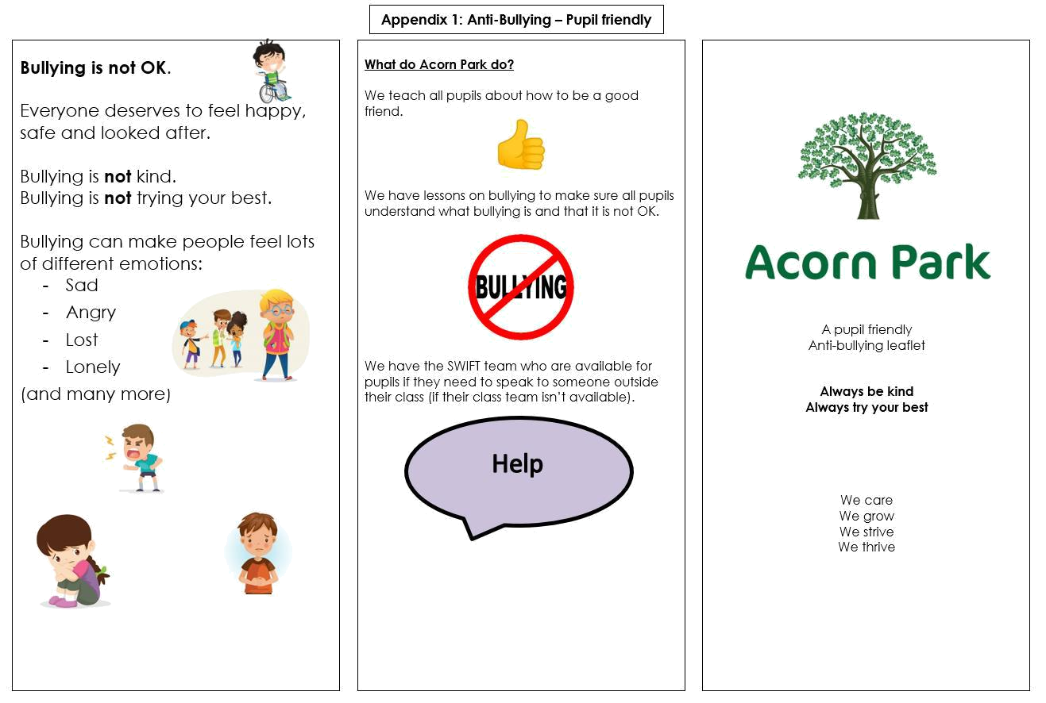
What Brinksway School Do?


We have a pastoral leader or any member of staff who is here to listen, help and resolve your problem.
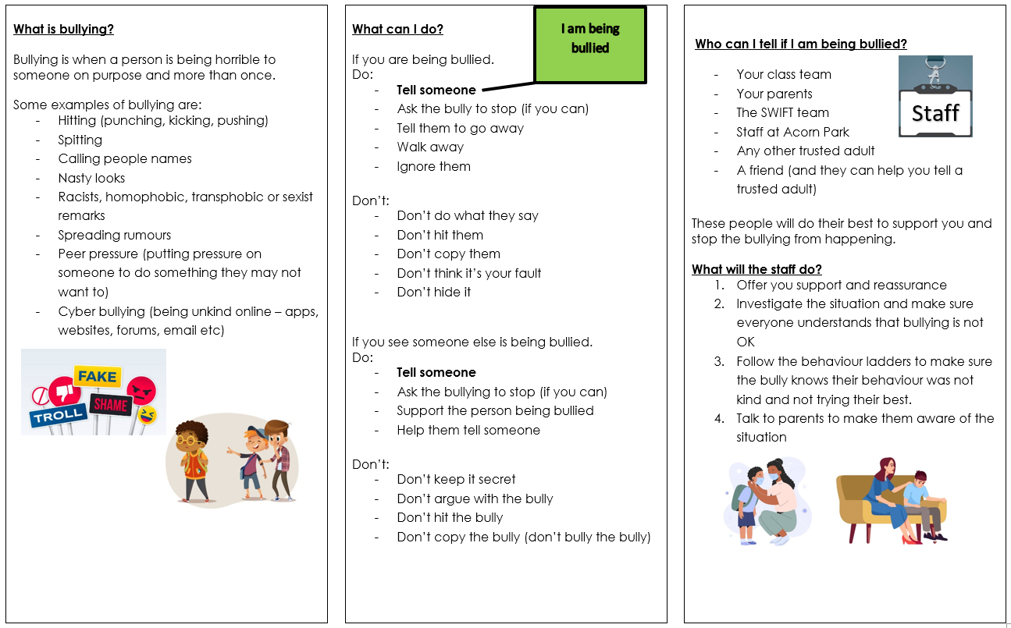
- Your parents
- Pastoral Manager
- Staff at Brinksway
- Any other trusted adult
- A friend (and they can help you tell a trusted adult)



We are part of the Outcomes First Group Family,by

working together we will build incredible futures by

empowering vulnerable children, young people and

adults in the UK to be happy and make their way in the

world

Document Name:

