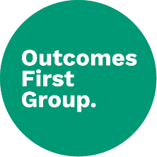
Curriculum Policy

To be read in conjunction with:
- Accessibility Plan
- Equal Opportunities Policy
- E-Safety Policy
- Special Educational Needs and Inclusion
- SMSC and British Values
- Assessment
- Teaching and Learning

Policy Number | 1.0
Review Date | September 2025
Owner | Carla Adams-McCoy

Document History

Version | Comments/amendments | Name | Date
1.0 | First Version | Carla Adams-McCoy | September 2024

Contents

Introduction 2

Pre-Formal Pathway 3

Semi-Explore Pathway 5

Semi-Formal Pathway 7

Formal Pathway 9

Assessment Cycle – All Pathways 11

Communication 12

Therapies 13

Interventions 13

Education outside the classroom, including visits and visitors (Cultural Capital) 14

Enrichment Curriculum 15

Social, Moral, Spiritual and Cultural education, and British values 15

Impact 15

Page 1 of 16

Introduction

At BRINKSWAY SCHOOL, we believe each learner is entitled to a curriculum that is personalised and appropriate for them. All our learners have an Education, Health and Care Plan (EHCP) and require modified approaches to achieve their aspirations and goals. Our curriculum reflects the main EHCP areas and addresses learners’ individual needs and barriers to learning so that each learner can develop to reach their true potential.

Learners at BRINKSWAY SCHOOL follow one of four learning pathways: Pre-Formal, Semi-Explore, Semi-Formal or Formal. The school ensures that there is fluidity between pathways, allowing for a personalised approach that enable learners to benefit from approaches from other pathways and to move between pathways if they develop.

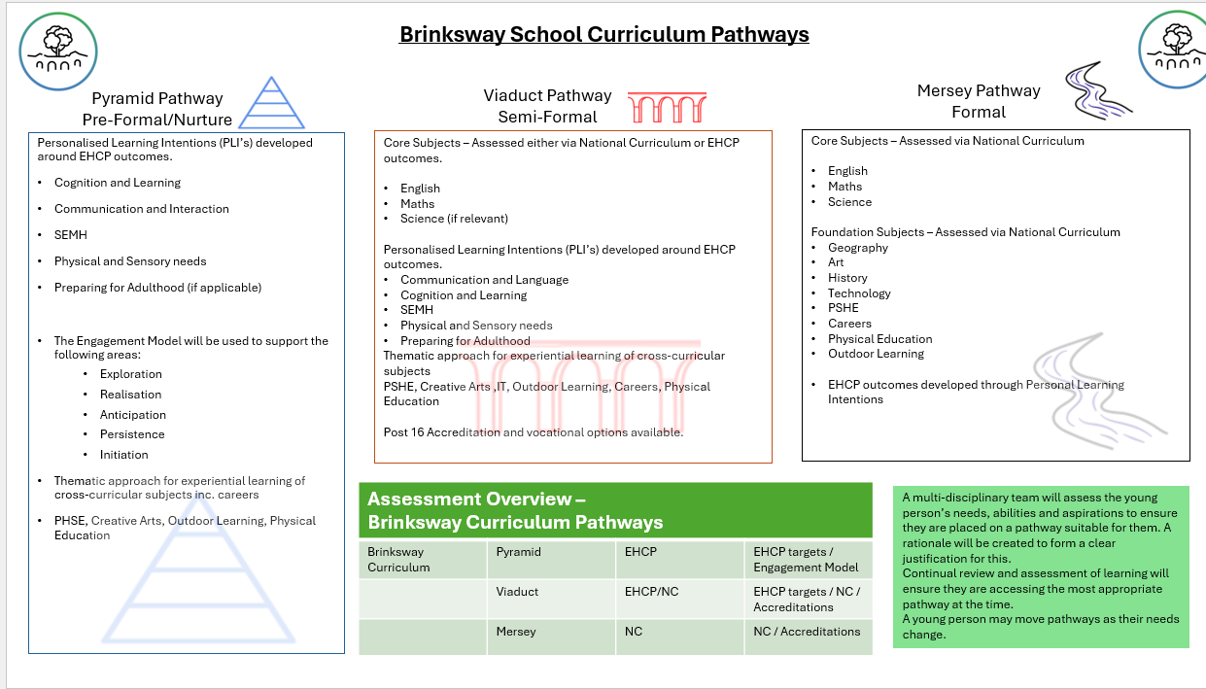

Page 2 of 16

Pre-Formal Pathway

Learner Profile

The learners following the pre-formal curriculum have profound and multiple learning difficulties and complex needs, usually working within the Engagement Model (P Levels P1-P4). Each

of our learners is unique, requiring staff to take a holistic approach centred in a multi-sensory environment around the physical needs, strengths and interests of each learner whilst acknowledging how they best learn. The focus is upon enabling the learners to establish positive interactive relationships with others and to proactively explore the world around them, gaining environmental control skills. All learners are given maximum opportunity to achieve the highest level of independence possible.
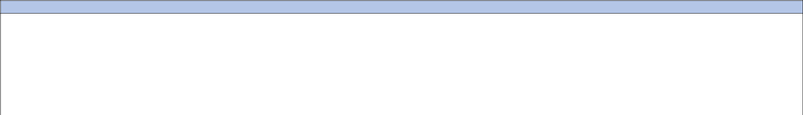

Intent

We provide a personalised curriculum that:

Ensures learning is holistic, with all parts of the curriculum interconnected;

Builds in sufficient time for learners to repeat, practise and consolidate skills;

Recognises learners’ need for consistency;
Develops learners’ levels of engagement by finding out what interests and motivates them;

Places learners’ targets at the centre of the curriculum with their interests as the teaching vehicle. Some learners in this group are working beyond the Engagement Model in specific

areas, and are supported to access a semi-formal curriculum in those areas;
Recognises learners’ need for different levels of sensory stimulation.

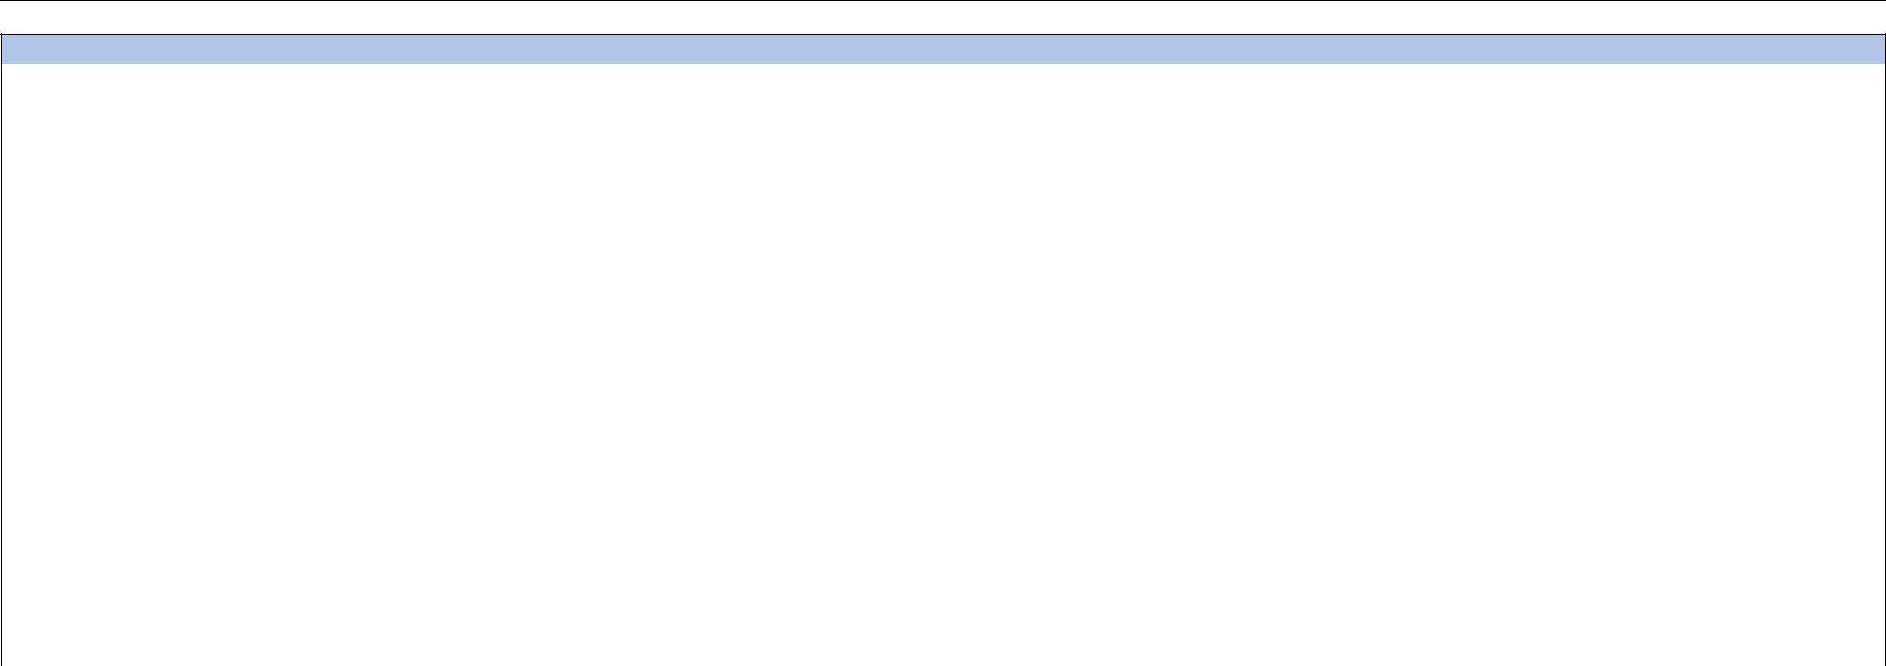

Implementation
Whole School Approach | Lessons | Curriculum Areas
We have common themes in place across the curriculum, | We aim to build the early communication, social and | Equals Curriculum:
which aim to be interesting, engaging and appropriate for | emotional, and cognitive skills that are the foundation of | Our classes follow termly topics from the relevant Key Stage
our learners and that provide relevant learning contexts for | learning. The curriculum acknowledges the importance of | Long Term Plan. The subject areas and lesson objectives are
them to grow. The topics we teach are the vehicle for new | movement and play in a child’s development, and the need | largely taken from the EQUALS curriculum, building to
learning to take place and to enable learners to make | our learners have for sensory and multi-sensory approach | provide learners the opportunity to make progress against
progress. The pre-formal curriculum is, at its heart, a | to learning. To help achieve a learner’s full potential, our | their EHCP, learner-specific targets. The EQUALS curriculum
personalised learning journey for each learner. | lessons are: | areas are:
 | Multi-Sensory | My Communication and Social Relationships
 | Tactile | My Cognition, Challenge and Sensory
 | Experiential | My Physical and Wellbeing
 | Exploratory | My Creativity
 | Stimulating | My Independence
 | Relevant | Enrichment
 | Individualised
 | To aid communication in lessons, we use a wide range of
 | communication methods. On the pre-formal curriculum you
 | might see use of:
 | Body movements/Makaton/Canaan Barrie Sign System

Page 3 of 16

Facial expression

Eye movements/tracking
Mouthing

Vocalisations

Increased processing time
Intensive Interaction – reactive to proactive (reaching out)

to interactive

Sensory cues – smells, music of reference
Objects of reference with single word use

Photograph symbols

Big Mack interactive buttons

In addition, some learners can access therapies or interventions if needed (see Therapies and Interventions sections).

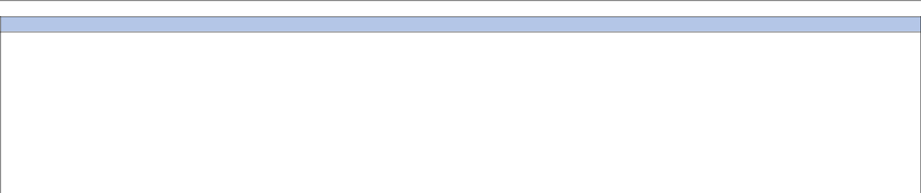

Assessment

Learner progress is assessed on an ongoing basis, with staff capturing evidence regularly using an interactive recording tool called Evidence for Learning (EfL) and the Engagement Model. The Engagement Model is used as a national assessment tool to help support learners who are working below the level of the National Curriculum and are not engaged in subject-specific study. The learners focus on developing the engagements skills of exploration, realisation, anticipation, persistence, and initiation. These skills are monitored throughout the year to moderate the level of engagement on the pre- formal curriculum. Evidence collected includes observations, photographs, videos and learners’ work. Parents and carers can access EfL to see the progress of their child and are able to add supportive comments.

Progress is assessed against learner-specific set targets taken from a bespoke framework consisting of ‘I will’ statements suitable for the pathway. Progress towards personal targets is reviewed at key points through the year, with new targets being set as appropriate in a cycle of ‘assess, plan, review, do’. Targets are set to support the learners work towards their long-term goals, as set in the EHCP SEND profiles. As a short-term target is met, a new target that will further them towards their overall, long term goal will be set.

Page 4 of 16

Semi-Explore Pathway
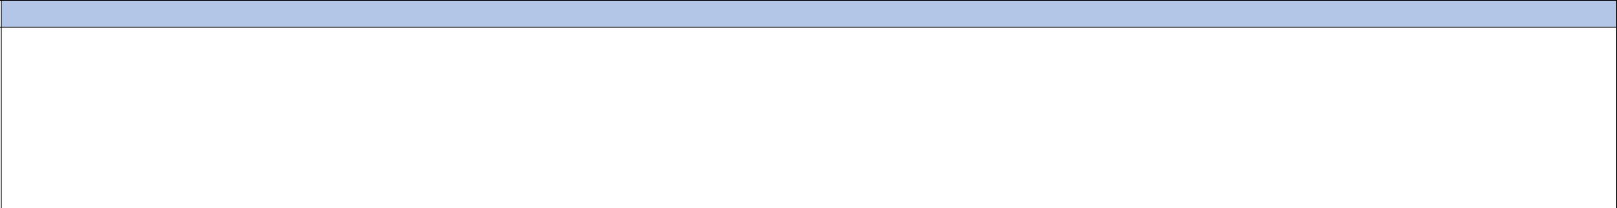

Learner Profile

Learners following the semi-explore curriculum have complex SLD, SLD/Autism usually working within the Engagement Model (P Levels P1-P4) or the pre-key stage standards (P Levels P4-P5). These learners have considerable sensory sensitivities that may be expressed both through the five main senses of touch, hearing, sight, taste and smell, but may also be evident within the kinaesthetic, proprioceptive and vestibular senses.

Through their lessons, our learners learn to trust the adults and the adults learn about the learners’ abilities and preferred communication approaches, their feelings, their likes and dislikes. If the learners have not yet built up a repertoire of interests, we can then find objects and activities of interest through the safe and secure ‘friendship’ that has developed through the sessions. When these interests have been established, they can be used to motivate the learners to communicate, express themselves and develop independence.

Intent

We provide a personalised curriculum that:
Gives breadth of challenging experience that celebrates all achievements. Some learners in this group are working beyond the Engagement Model in specific areas, and are supported to

access a semi-formal curriculum in those areas;

Gives opportunities for learners to extend their learning and skills through experiencing a wide range of activities;
Promotes independence through developing skills that enable learners to make their emotional and physical needs known.

Implementation
Whole School Approach | Lessons | Curriculum Areas
Overarching themes are in place, which have significance | Growth and development only happen when a learner feels | Our classes follow termly topics from the relevant Key Stage
for individual learners and society and provide relevant | safe, settled, secure and happy; these elements are at the | Long Term Plan. The subject areas and lesson objectives are
learning contexts. | heart of all we do, ensuring learners feel welcome and a | largely taken from the EQUALS curriculum, building to
 | part of their class and the wider school community. To help | provide learners the opportunity to make progress against
 | achieve a learner’s full potential, our lessons are: | their EHCP, learner-specific targets. The EQUALS curriculum
 | Multi-sensory | areas are:
 | Tactile | My Sensory Play
 | Exploratory | My Independence
 | Stimulating | My Creativity
 | Relevant | My Communication
 | Individualised | My Outdoor School
 |  | My Physical Wellbeing
 | To aid communication in lessons, we use a wide range of | Enrichment
 | communication methods. On the semi-explore curriculum
 | you might see use of:
 | Symbols
 | Learning through exploring
 | Objects of reference
 | Photo support/visual use

Page 5 of 16

Intensive Interaction

Chat boards
Now and Next prompts

Big Mack interactive buttons and Talking Tins

Sensory regulation/sensory diet

PECS (Picture Exchange Communication System)
Songs of reference/for transition

Social stories
signing

AAC (Augmentative and Alternative Communication)

Key word language

In addition, some learners can access therapies or interventions if needed (see Therapies and Interventions sections).

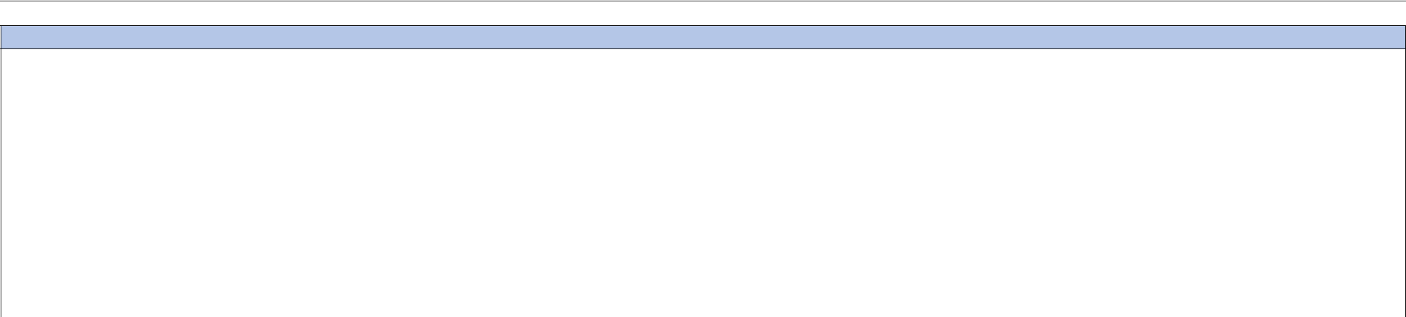

Assessment

Learner progress is assessed on an ongoing basis, with staff capturing evidence regularly using an interactive recording tool called Evidence for Learning (EfL) and the Engagement Model. The Engagement Model is used as a national assessment tool to help support learners who are working below the level of the National Curriculum and are not engaged in subject-specific study. The learners focus on developing the engagements skills of exploration, realisation, anticipation, persistence, and initiation. These skills are monitored throughout the year to moderate the level of engagement on the semi-explore curriculum. Some learners in years 2 and 6 will be assessed using the pre-key stage standards. These provide a statutory assessment of learners engaged in subject-specific study who are working below the overall standard of the national curriculum tests and teacher assessment framework. Evidence collected includes observations, photographs, videos and learners’ work. Parents and carers can access EfL to see the progress of their child and are able to add supportive comments.

Progress is assessed against learner-specific set targets taken from a bespoke framework consisting of ‘I will’ statements suitable for the pathway. Progress towards personal targets is reviewed at key points through the year, with new targets being set as appropriate in a cycle of ‘assess, plan, review, do’. Targets are set to support the learners work towards their long-term goals, as set in the EHCP SEND profiles. As a short-term target is met, a new target that will further them towards their overall, long term goal will be set.

Page 6 of 16

Semi-Formal Pathway

Learner Profile

The semi-formal curriculum supports a wide range of learners typically working between standards 1 to 6 of the pre-key stage standards i.e. between P5 (P Level) and NC Levels 1-2. In addition to their severe or moderate learning difficulties, they may also face other barriers to learning such as physical difficulties, medical conditions, social and emotional needs, sensory processing, visual or hearing impairments, communication difficulties. The semi-formal curriculum incorporates the EQUALS Schemes of Work and has a strong foundation of life skills. These skills promote independence and communication skills allowing the learner to make progress to the best of their ability.

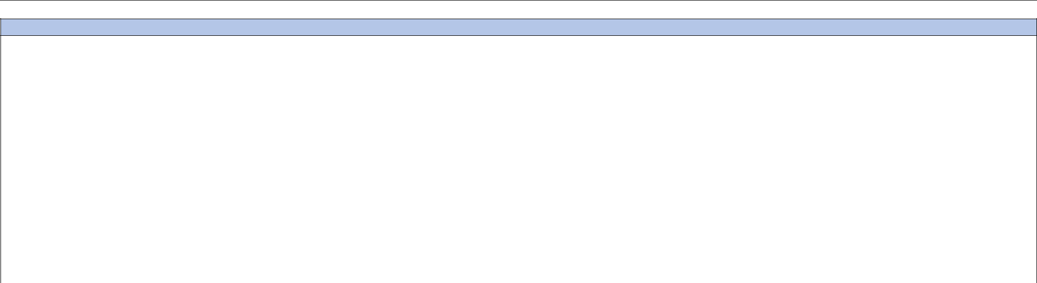

Intent

We provide a personalised curriculum that:

Promotes independence by developing skills that will allow learners to be as independent as possible; Develops independence by providing explicit instructions and sufficient time for learners to repeat, practise, maintain and consolidate skills; Challenges and stretches learners with a strength in English and Maths to reach their full potential; Develops learners’ levels of engagement by finding out what interests and motivates them; Provides meaningful contexts for learning that use real-life materials and experiences, concrete resources and practical everyday activities so that learners link experiences and make connections;

Supports learners to develop an awareness of, and interest in, themselves and their immediate surroundings and environment;

Recognises the importance of play and games as motivational curriculum activities that allow repetition and consolidation of skills;

Recognises that when using imagination and thinking of something that is not immediately present, children with SLD may need prompts to recall an experience;

Includes activities that move beyond memory-building activities to take part in supported thinking and problem-solving activities;
Provides opportunities for generalising and applying skills and knowledge across curriculum areas;

Acknowledges that the physical wellbeing and development of our SLD learners is important;

Recognises some of our learners may not be physically able to complete practical processes without full support, but that they should be involved in choice and decision-making about the

process.

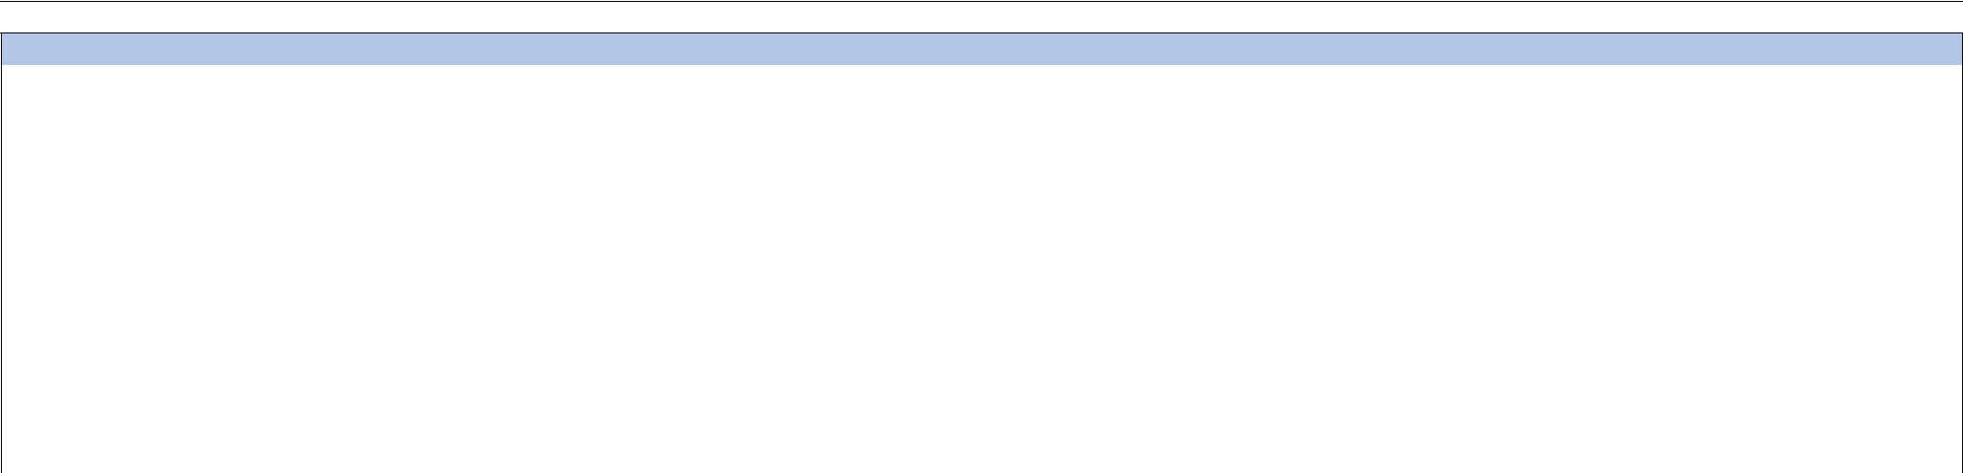

Implementation
Whole School Approach |  | Lessons |  |  | Curriculum Areas
We have common themes in place across the curriculum, |  | On this pathway we aim to minimise the learning barriers |  | Our classes follow termly topics from the relevant Key Stage
which aim to be interesting, engaging and appropriate for |  | experienced by individual learners. We aim to equip our |  | Long Term Plan. The subject areas and lesson objectives are
our learners and that provide relevant learning contexts for |  | learners with the skills, knowledge and passion to |  | largely taken from the EQUALS curriculum, building to
them to grow. The topics we teach are the vehicle for new |  | participate and contribute within society, empowering them |  | provide learners the opportunity to make progress against
learning to take place and to enable learners to make |  | to live active and fulfilled lives. It is essential that learning is |  | their EHCP, learner-specific targets. The EQUALS curriculum
progress. |  | purposeful, immersive, fun and interactive; therefore, our |  |  | areas are:
 |  | lessons include: Collaborative learning; Active learning; |  | Key Stage 2 | Key Stage 3 | Key Stage 4
 |  | Multi-sensory activities; Differentiation; Individualisation.
 |  |  |  | My | My | English
 |  | To aid communication in lessons, we use a wide range of |  | Communication | Communication
 |  | To aid communication in lessons, we use a wide range of |  | My Thinking and | My Thinking and | Maths
 |  | communication methods. On the semi-formal curriculum |  | My Thinking and | My Thinking and | Maths
 |  | communication methods. On the semi-formal curriculum |  | Problem Solving | Problem Solving
 |  | you might see use of: |  | Problem Solving | Problem Solving

Page 7 of 16

 | Photo support visuals |  | My Play and | My Play and | ICT
 | Visual symbols |  | Leisure | Leisure
 | Now and Next prompts |  | My Independence | My | Life Skills
 | Makaton signing |  |  | Independence
 | Visual timetable |  | My Creativity | My Creativity | Creativity
 | Chat mats
 | Chat mats |  | The World About | The World | Work Skills
 | PODD books |  | The World About | The World | Work Skills
 | PODD books |  | Me | About Me
 | Social stories |  | Me | About Me
 | Social stories |  | My Outdoor | My Outdoor | PSHE
 | Colourful semantics |  | My Outdoor | My Outdoor | PSHE
 | Colourful semantics |  | School | School
 | Verbal communication |  | School | School
 | Verbal communication |  | My Physical | My Physical | My Physical Wellbeing
 | Key word language |  | My Physical | My Physical | My Physical Wellbeing
 | Key word language |  | Wellbeing | Wellbeing
 |  |  | PSHCE | PSHE | Social
 |  |  | (Beech/Chestnut) |  | Communication
 |  |  | Zones of | Zones of | My Outdoor School
 |  |  | Regulation | Regulation
 |  |  | ICT | ICT | Zones of
 |  |  |  |  | Regulation
 |  |  | Enrichment | Enrichment | Enrichment
 |  |  | Swim
In addition, some learners can access therapies or interventions if needed (see Therapies and Interventions sections).


Assessment

Learner progress is assessed on an ongoing basis, with staff capturing evidence regularly using an interactive recording tool called Evidence for Learning (EfL). Evidence collected includes
observations, photographs, videos and learners’ work. Parents and carers can access EfL to see the progress of their child and are able to add supportive comments.

Progress is assessed against learner-specific set targets taken from a bespoke framework consisting of ‘I will’ statements suitable for the pathway. Progress towards personal targets is reviewed at key points through the year, with new targets being set as appropriate in a cycle of ‘assess, plan, review, do’. Targets are set to support the learners work towards their long-term goals, as set in the EHCP SEND profiles. As a short-term target is met, a new target that will further them towards their overall, long term goal will be set.

The pre-key stage standards focus on key aspects of English reading, English writing and Mathematics at the end of years 2 and 6. Reading ages, are also assessed. Our Key Stage 4 learners can work towards achieving ASDAN accreditations: Transition Challenge and Pupil Progress. In Key Stage 5, they can work towards completing units in OCR Life and Living Skills.

Page 8 of 16

Formal Pathway

Learner Profile

Learners on our formal curriculum have moderate learning difficulties, alongside associated complexities, such as SEMH, physical and visual impairments. Learners access a range of

National Curriculum subjects for their Key Stage, modified to accommodate their developmental level and special educational needs. Life skills and independence skills also form a part of

the curriculum, in addition to the more traditional formal learning subjects. As the term ‘formal’ implies, there is a high level of structure. We nevertheless avoid making the formal

curriculum too abstract; teachers ensure that learning is linked to practical activities and consolidated and applied in practical sessions. Older learners will pursue accreditation pathways
(e.g. Entry Level/Level 1/GCSE as appropriate).

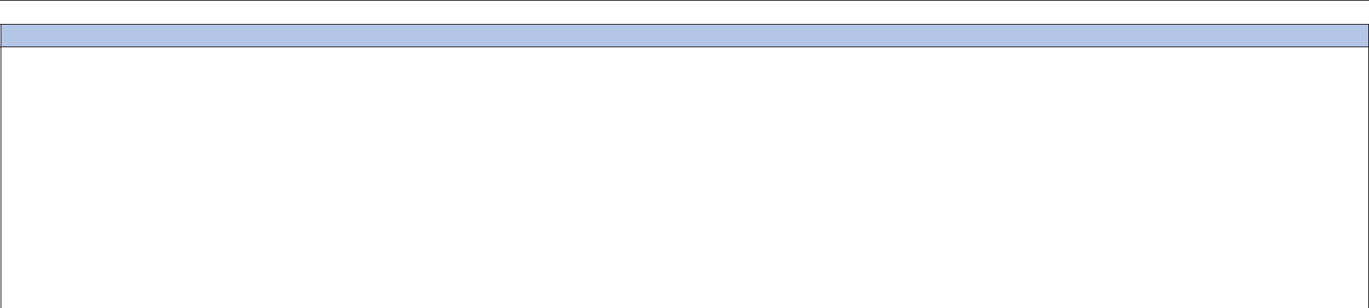

Intent

We provide a curriculum that:

Is primarily accessible to those learners’ with moderate learning difficulties in their learner profile;

Supports learners to develop their interests as well as their skills and knowledge;
Is a planned programme of objectives, content, learning experiences, resources and assessment based on, but not exclusive to, the National Curriculum 2014;

Includes life skills and independence skills;

Ensures learning is linked to practical activities and consolidated and applied in practical sessions;

Is interconnected to encourage the transference of skills and knowledge across the learning pathway, whilst allowing for subject-specific knowledge and understanding to be embedded; Recognises some of our learners may not be physically able to complete practical processes without additional support, but that they should be involved in choice and decision-making about the process;

Through collaboration with a range of other professionals, is accessible to all learners as part of a bespoke provision of supported access and personalised approaches e.g. SaLT input in
supporting non-verbal learners to use AAC devices to communicate about their learning;

Enables older learners to pursue accreditation pathways (e.g. Entry Level awards and exams).

Page 9 of 16



Implementation
 | Whole School Approach |  | Lessons |  |  | Curriculum Areas
 | We have common themes in place |  | On the formal pathway we teach a |  | The pathway follows a traditional secondary approach, offering a broad and balanced curriculum. Learners
 | across the curriculum, which aim |  | range of qualifications, |  | follow a timetable and transition around the school to different lessons. Transitioning from classroom to
 | to be interesting, engaging and |  | accreditations and syllabuses. We |  | classroom is a crucial part of developing independence and helps prepare learners for college and/or
 | appropriate for our learners and |  | see the formal curriculum as a tool |  | employment in the future. Classes have a pastoral base with their form teacher and are taught adapted
 | that provide relevant learning |  | to enable the learner to become |  | national curriculum content delivered by specialist teachers. The curriculum areas at each key stage are:
 | contexts for them to grow. Formal |  | an active and engaged contributor |  | Key Stage 1/2 | Key Stage 3 | Key Stage 4/5
 | learners follow a modified |  | to our society. Our lessons include: |  | National Curriculum: | National Curriculum: | Vocational courses:
 | National Curriculum across Key |  | Subject-specific learning |  | English | English | English
 | Stages 1 – 4. In Key Stage 5, |  | Collaborative learning |  | Maths | Maths | Maths
 | learners follow a range of |  | Active learning |  | Science | Science | Science
 | accredited courses. |  | Differentiation |  | PSHE | PSHCE | PSHCE
 | accredited courses. |  | Differentiation |  | Computing | Computing | Computing
 |  |  | Individualisation |  | Computing | Computing | Computing
 |  |  | Individualisation |  | PE | PE | Life Skills
 |  |  | Vocational learning |  | PE | PE | Life Skills
 |  |  | Vocational learning |  | Humanities  Science  Art & DT | Science | PE
 |  |  | To aid communication in lessons, |  | Music | Art & DT  Humanities  Also: | Work Experience
 |  |  | To aid communication in lessons, |  |  | Life Skills | Careers
 |  |  | we use a wide range of |  |  |  | Social and Leisure
 |  |  | communication methods. On the |  | Also: | Work Experience | College Links
 |  |  | formal curriculum you might see |  | Life Skills | Careers | Enrichment
 |  |  | use of: |  | Zones of Regulation | Enrichment
 |  |  | Visual symbols |  | Enrichment
 |  |  | Makaton signing
 |  |  | Visual timetable
 |  |  | Verbal communication
 |  |  | Written language
In addition, some learners can access therapies or interventions if needed (see Therapies and Interventions sections).


Assessment

Learner progress is assessed on an ongoing basis, with staff capturing evidence regularly using an interactive recording tool called Evidence for Learning (EfL). Evidence collected includes

observations, photographs, videos and learners’ work. Parents and carers can access EfL to see the progress of their child and are able to add supportive comments.

Progress is assessed against learner-specific set targets taken from a bespoke framework consisting of ‘I will’ statements suitable for the pathway. Progress towards personal targets is reviewed at key points through the year, with new targets being set as appropriate in a cycle of ‘assess, plan, review, do’. Targets are set to support the learners work towards their long-term goals, as set in the EHCP SEND profiles. As a short-term target is met, a new target that will further them towards their overall, long term goal will be set.

Page 10 of 16

Assessment Cycle – All Pathways


Setting Targets

Each learner has long-term targets for the 4 EHCP areas.

The targets are broken down into short-term targets to
make them manageable.

The targets are moderated and approved when SMART.

Parents/carers are involved in the target-setting process.


Assess, Evaluate and Moderate | Plan

Evidence is recorded on EfL, assessing the progress made
against the targets.

Regular moderation of evidence is undertaken by pathway
teams.


Observe

Evidence is recorded against targets.

Evidence includes observations, photographs, videos and
learners’ work.

Evidence of learning is mapped to assessment
frameworks.


Broad and balanced curriculum which is aligned to the learning outcomes and targets in the EHCPs of learners.

Learning environments and strategies put in place to help
learners meet their targets.


Working Together

Teaching staff work with a multi-agency team to:
  - Set targets for learners
- Plan and deliver an appropriate curriculum
    - Conduct observations

Senior leaders support the setting of targets and
moderation process.

Page 11 of 16

Communication

Communication

We offer a Total Communication approach. We use Widgit symbols and VI-friendly visual support for our learners. Learner need defines the communication support offered to each learner; examples might include AAC, Makaton, PECS, etc. Communication support also differs across our different pathways, and is highlighted in the communication flowchart. This flowchart highlights some of the communication methods we might also expect to see across the different curriculum pathways. We work closely with our Speech and Language therapist to incorporate individual learner programmes into the school day.

Communication Flowchart

Pre-Formal Curriculum | Semi-Explore Curriculum | Semi-Formal Curriculum | Formal Curriculum
Body movements/signs | Symbolic understanding with photographs | Photo support visuals | Visual symbols
Facial expression | Learning through exploring | Visual symbols | Makaton
Eye movements/tracking | Objects of reference | Now and Next | Visual timetable
Mouthing | Photo support/visual use | Makaton | Verbal communication
Intensive interaction | Intensive Interaction | Visual timetable | Written language
Vocalisations | Now and Next
Increased processing time |  | PECS
Intensive Interaction – reactive to proactive | Sensory regulation/sensory diet
(reaching out) to interactive | PECS
Sensory cues – smells, music of reference | Songs of reference/for transition | Social stories
Objects of reference with single word use | Social stories | Colourful semantics
Photograph symbols | Core word curriculum | Verbal communication
Use of explorative sounds in the environment | Makaton | Key word language
 | AAC
 | Key word language

Page 12 of 16

Therapies


Therapies

Some learners have additional needs identified in their EHCP which require support from a therapist. To ensure that these needs are met, there are a range of professionals and therapists who are part of the Educational Team and work alongside the class team and parents, either by providing individual plans or by supporting the delivery of programmes within the class.

If required, learners have access to on site Speech and Language, Occupational Therapy and Psychologists. Therapists offer support in a range of ways:
Supporting the pastoral team to show them how they can work on developing learners’ skills across a range of learning opportunities in school;

Working in partnership with the pastoral team to develop a clear and holistic picture of learners’ skills and how these impact on their learning, behaviour and social skills; Providing specific and targeted support for learners as needed.

Interventions / Support


Interventions

Emotional Health and Wellbeing

Some of our learners, at some times in their lives, benefit from a more specific type of programmed support. In such cases we make use of our Pastoral Lead

The Pastoral Lead is able to work to support individuals who may have experienced or be experiencing pressures that impact on their emotional health and wellbeing and therefore
impacting on their daily functioning. The Pastoral Lead makes use of methods such as:

Positive Behaviour Support

Emotional Regulation and Support

Mental Health Support

Page 13 of 16

Sensory Circuits

Sensory Circuits interventions are available for those learners who need help settling into their school day. The aim of the Sensory Circuits programme is to facilitate sensory processing and sensory integration, and to allow learners to be in the optimum state of alertness, ready for learning. The children participate in a short 10–15-minute session of activities designed to improve brain processing efficiency, and they generally find that the circuit is a fun way to start the day. Sessions are run in the morning before learners attend their first lesson.

Sensory Diets

Identified learners have a sensory diet, a programme of sensory activities that are specifically scheduled into their day to ensure they’re getting the input their bodies need. The sensory

diets assist with attention, arousal and adaptive responses.
.

Zones of Regulation

We recognise the importance of promoting positive mental health and emotional wellbeing in our learners and their families. We aim to create an open culture around the discussion of
mental health and wellbeing and to empower our children be able to regulate their emotions. By implementing the Zones of Regulation curriculum we aim to teach our learners to

identify emotions in themselves and others and provide them with a bank of strategies to help regulate their emotions and improve their wellbeing.

Zones of Regulation is a curriculum based around the use of four colours to help children self-identify how they’re feeling and categorise it based on colour. The curriculum also helps children better understand their emotions, sensory needs and thinking patterns. The children learn different strategies to cope and manage their emotions based on which colour zone they’re in. Additionally, Zones of Regulation helps children to recognise their own triggers, learn to read facial expressions, develop problem-solving skills, and become more attuned to how their actions affect other people.

Education outside the classroom, including visits and visitors (Cultural Capital)

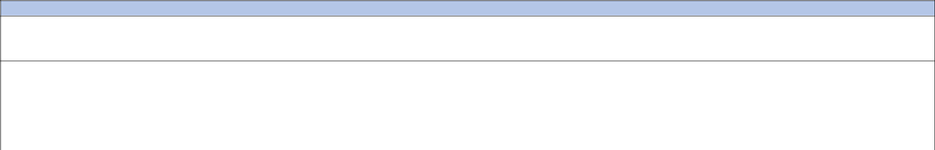
Education outside the classroom, including visits and visitors

Educational visits and external visitors to school play a significant part in our curriculum offer. We believe our learners learn best through experience and therefore we aim for all learners
to engage in learning outside the classroom. These experiences are often linked to curriculum topics; however, they can be standalone events. Examples are:

In Primary:
Visits/assemblies by roles in the local community
Offsite PE activities

Variety of museums and places of worship

Parks and Supermarkets

We are continuing to develop this offer as the school and curriculum is established linking enrichment activities to enhance our offer. Pupils have participated in Jump Space, Animal Therapy and Music therapy

Page 14 of 16

Enrichment Curriculum


Enrichment Curriculum

Our enrichment curriculum provides the opportunity for learners to develop life-long skills and interests that can lead to greater independence and confidence and support them in later

life. Our wish is to develop our learners’ skills and talents in a very practical and hands on way. Such activities might include, amongst others:
Dance

Board/card games

Computers
Lego Club
And a range of lunchtime activities

Social, Moral, Spiritual and Cultural education, and British values

Social, Moral, Spiritual and Cultural education, and British values

We recognise that social, moral, spiritual and cultural education (SMSC) including British values plays a significant part in the personal development of our learners. SMSC is a dimension
of the whole school experience which makes the curriculum relevant, creative, stimulating and fun. It enriches the curriculum and ethos of our school.

Page 15 of 16

Page 16 of 16

