

Brinksway School Newsletter – Summer Term 1

Headteacher’s Welcome
Dear Parents, Carers, and Pupils,
Welcome back! I hope you all had a restful and enjoyable Easter break, filled with time to recharge, reconnect with family, and enjoy some well-earned rest.
As we begin the new half term, I’m excited about the opportunities and experiences ahead. This is always a busy and rewarding time of year with lots of trips, visits, and experiences planned as the weather improves. As always, we will be supporting every child to do their best and enjoy the learning journey along the way.
Thank you to families who have returned their school survey—your feedback is invaluable as we continue to strengthen our educational offer.
A special welcome goes to all the new families who have joined our school community. We’re delighted to have you with us.
Thank you for your continued support and partnership. Let’s make this half term a positive and productive one together.
Warm regards,
Carla Adams-McCoy, Headteacher

Highlights from Last Half-Term
Last half-term pupils enjoyed a wide range of trips and experiences. It is so important to develop their life experience and give pupils every opportunity to visit places in our community to enrich their learning.

✨ Tatton Park Trip
Abney Class had a magical day out at Tatton Park, diving into fairy tales and stories they’ve been studying in class. A memorable and immersive learning experience!

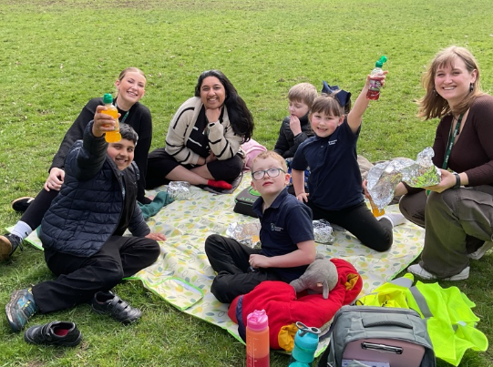
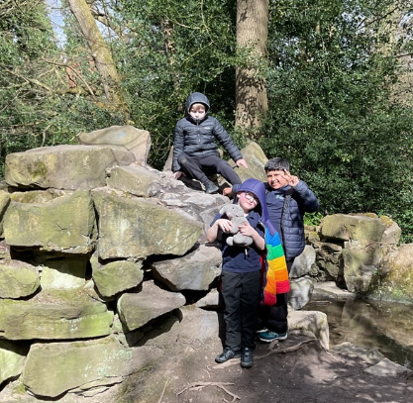

🏭 Quarry Bank Mill Visit
Woodbank and Thornfield Classes explored the Industrial Revolution firsthand with a self-led tour of Quarry Bank Mill, enriching their Humanities topic.
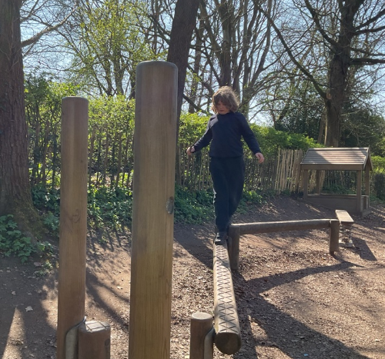

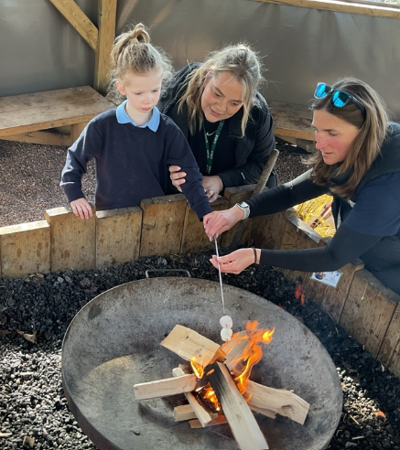
🐮 Farm Adventure
EYFS pupils visited a local farm to meet and pet animals as part of their learning about animal life. A fun, interactive and proud moment for all!

Special Celebration Days
We marked World Math’s Day, Earth Day, and Red Nose Day with fun and educational activities promoting numeracy, sustainability, and compassion.
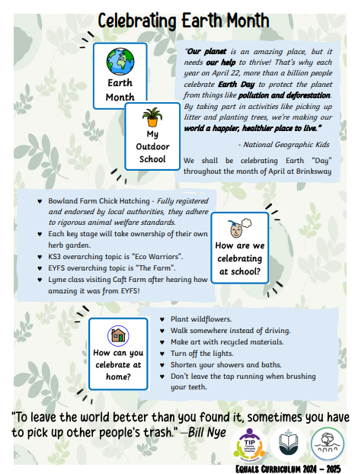
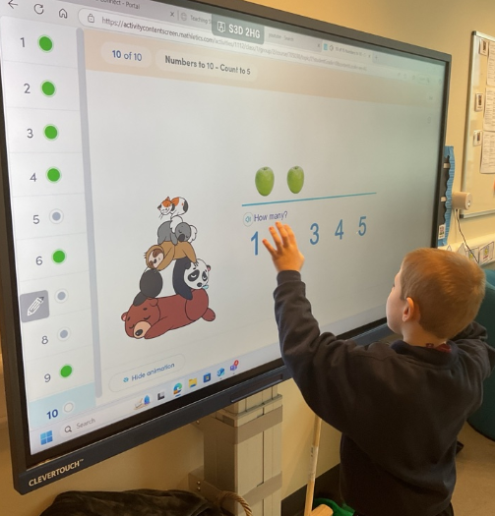

Sensory Circuits & QT Robot Support
A big thank you to our highly specialised Occupational Therapist Rachel Peek, who has worked tirelessly to support staff develop the environment and meet children's clinical needs. Pupils are benefitting from Sensory Circuits each morning. Rachel has supported and trained staff to deliver these sessions. Sensory diets are personalised plans designed to help learners regulate their sensory input throughout the day. They include various activities categorised as alerting, calming and organising, each serving different purposes in managing sensory need.
Alerting Activities - These activities increase alertness and energy levels. They are typically stimulating and can help individuals feel more awake and focused.
Organising Activities - These activities help individuals feel more grounded and focused, promoting a sense of stability. They often combine elements of both alerting and calming.
Calming Activities - These activities aim to reduce anxiety and help individuals relax. These are usually soothing and can help lower energy levels.

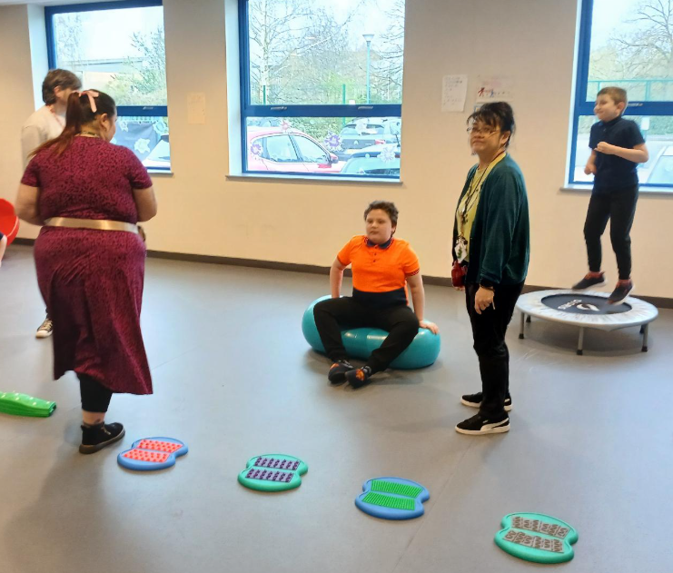

A big thank you to Julia Hunter (SALT and Clinical Lead) who has worked with Mrs Wheeler to set up QT robot interventions and for her support and training of SALT approaches for the staff. We are really proud of the environment we have created to clinically meet pupils' needs.

This Term at Brinksway
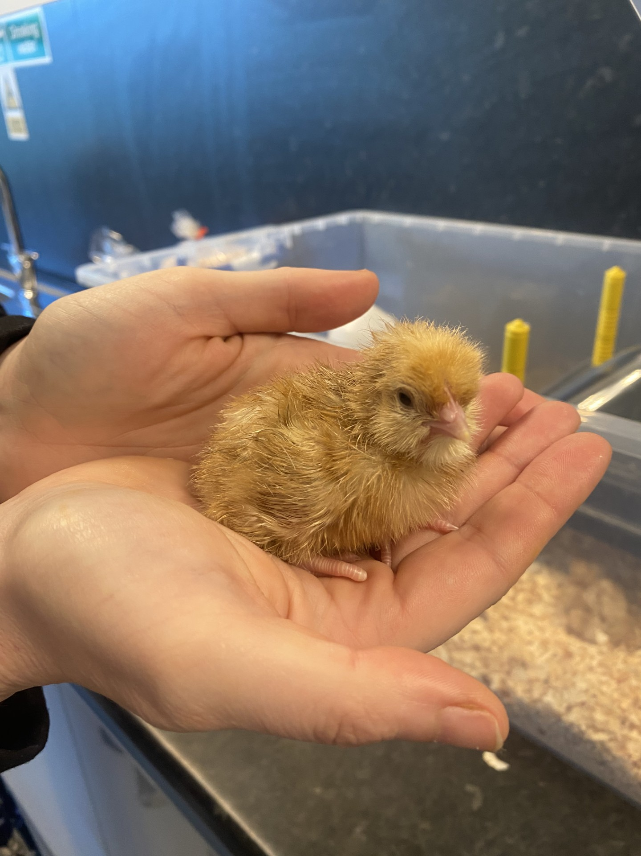
🐣 Chick Hatching at Bowlands Farm
As part of Earth Month, students are observing eggs hatching in class! This hands-on experience has inspired curiosity and care.
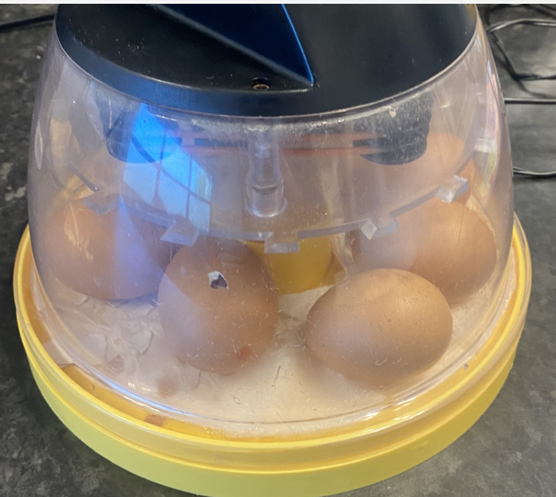

🐕 Animal Therapy & Jump Space
Animal handling, feeding and care continue to run on a rota alongside Jump Space visits—a specialist SEN Centre supporting EHCP targets.

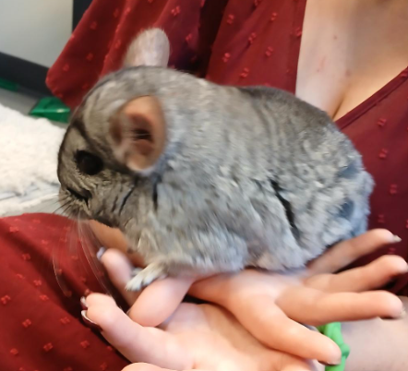
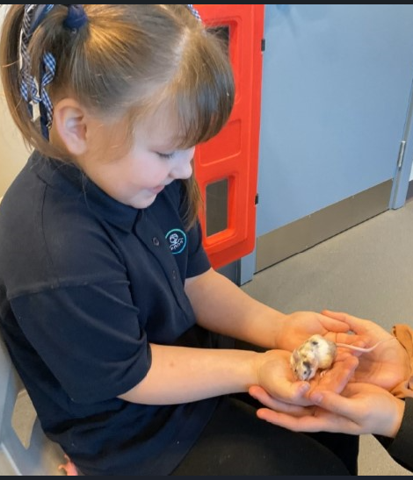

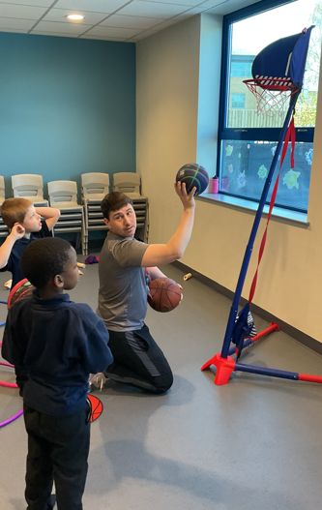
🏃 SEN PE Class
All pupils enjoyed a trial PE session from an external provider, building coordination and communication in an inclusive, supportive environment.

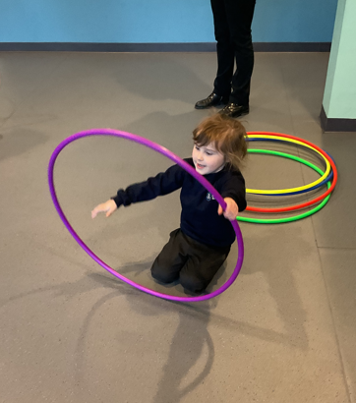

🎵 Music Therapy Begins!
This term, classes will participate in music therapy sessions, while KS2 students will also work toward a First Aid qualification and continue swimming lessons.
🤟 British Sign Language
We are further developing our use of BSL across the school to enrich communication for all pupils.

Easter Coffee Morning
A big thank you to everyone who joined us! Families connected over crafts and learned more about our INSPIRE behaviour system.
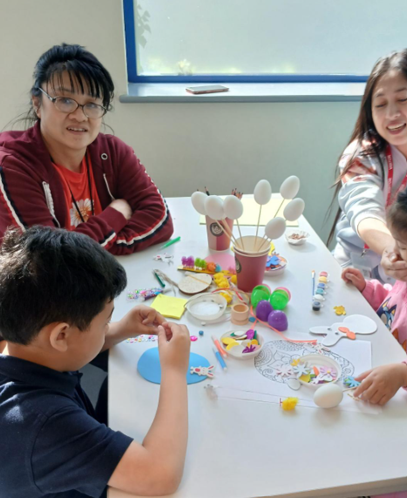
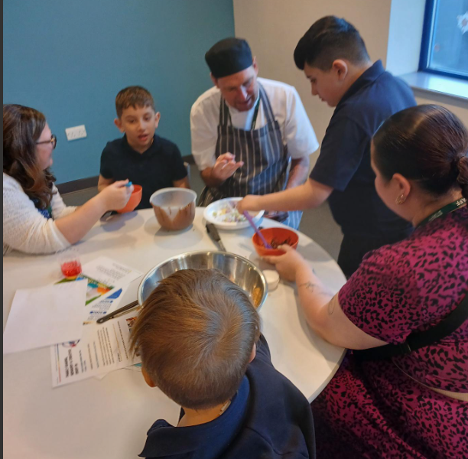
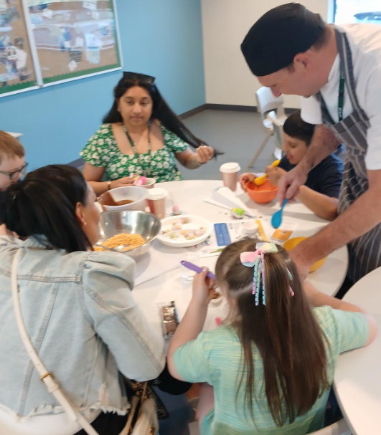

🏆 Congratulations to Dotty Rae, winner of the Easter Egg competition, and to Renesmee for her beautiful display!
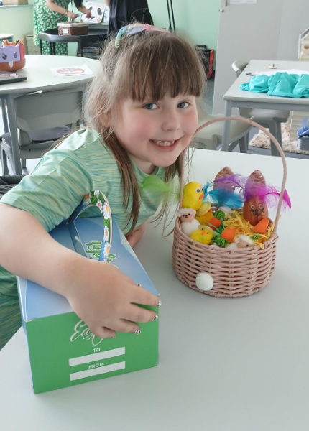

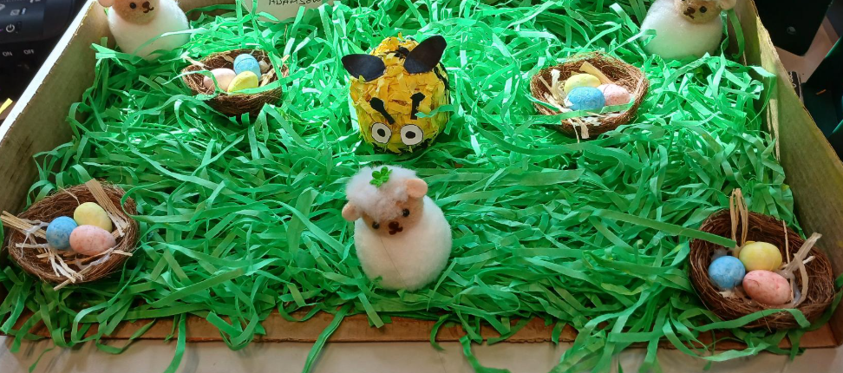

Upcoming Event: David from Disability Stockport
📅 May 12th, 1pm
David will speak about life with autism, supported by a video and VR experience. Please look out for the link from the office to confirm your attendance.

Staffing Updates
We are growing!
- Mrs. Bradshaw is now Ms. Arrowsmith
- New Appointments:
- Mrs. Quigley (Psychologist)
- Meghan (Therapy Assistant)
- Mrs. Wheeler – now Assistant Headteacher
- Mrs. Bridgeen Whittle – joining as Deputy Headteacher in June
- Miss Penny Silverwood – SENCO and Assistant Headteacher
- New Staff: Mr. Massey, Miss Oakley, Mrs Denton, Mr Griffith, Miss Houghton, Mrs. Rafique, Miss O Halloran (Teacher)
- Kim Robinson (Kitchen Staff)
Welcome to all our new team members!

Term Dates & Contact Updates
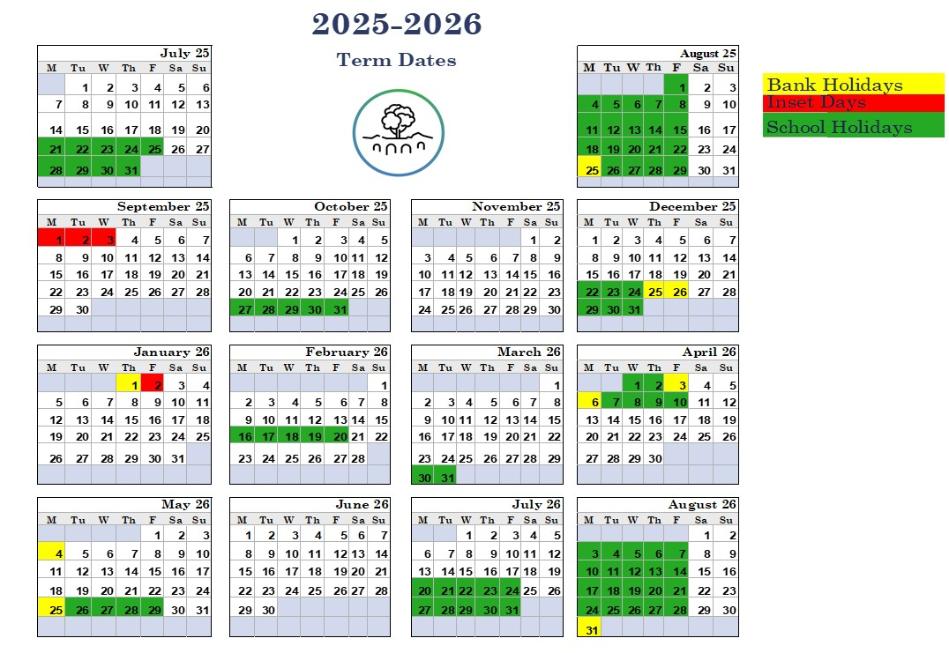
Please ensure the office has your most up-to-date contact details. If you’ve changed your number or address, call us on 0161 260 5376.

