

Newsletter Spring term 2

Headteacher’s Welcome
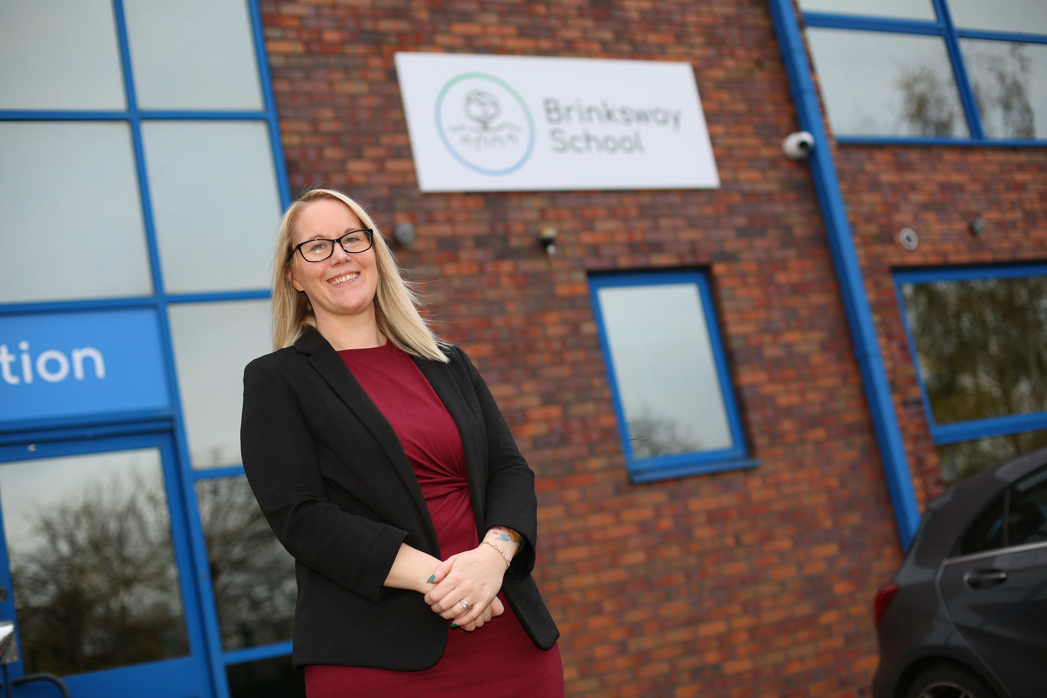
Dear Parents, Carers, and Students, A very warm welcome to this edition of our school newsletter! It’s always a pleasure to share the wonderful achievements, exciting events, and daily moments that make our school such a special place. Our students continue to amaze us with their enthusiasm for learning, kindness towards one another, and commitment to making our school community thrive. As we move through the term, I encourage everyone to take pride in their efforts, support each other, and embrace new opportunities. Thank you for your ongoing support—it truly makes a difference. I look forward to seeing many of you at our upcoming events and celebrating more successes together.
Warmest wishes,
Carla Adams-McCoy
Headteacher

World Book Day
Pupils and staff at Brinksway loved celebrating World Book Day and promoting a love of reading. Pupils took part in 'Read Your Way' Outcomes First Group's reading competition and dressed up as a book character for the occasion. Miss Shah, our English Lead, has also collected families responses regarding reading books, this is being set up and books will be sent home soon.
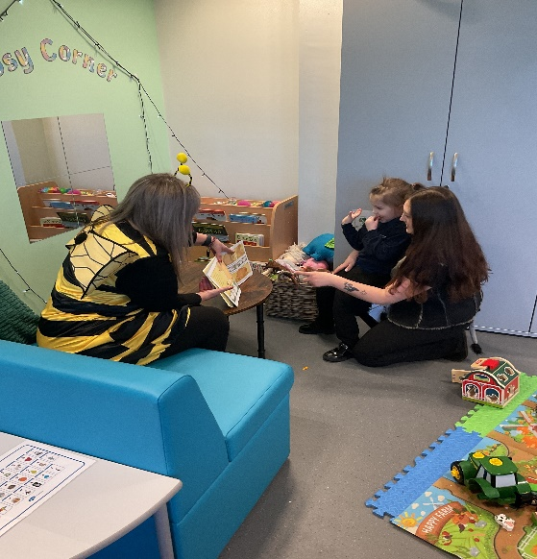
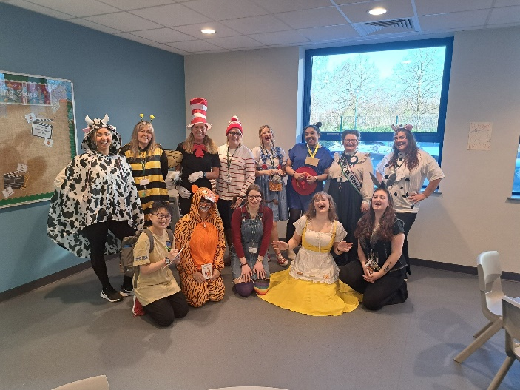

Animal Therapy
We are so proud of how pupils have engaged with the animals as they continue to enjoy their weekly sessions. Pupils have progressed from observing the animals, to holding them, petting them and feeding them. Pupils particularly enjoyed watching the lizard eating its meal worms!
We also welcome our two new resident horsefield tortoises to the team: Voldetort and Squirtle. Pupils have enjoyed coming to see them and take care of them daily.
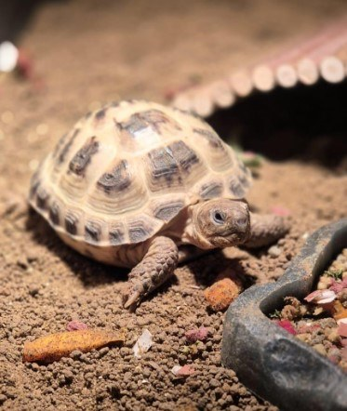
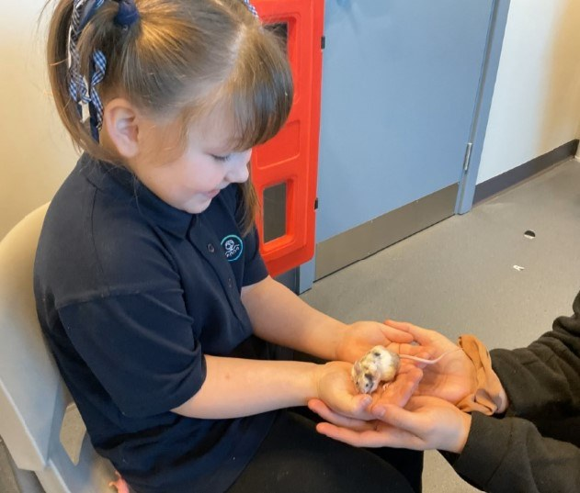
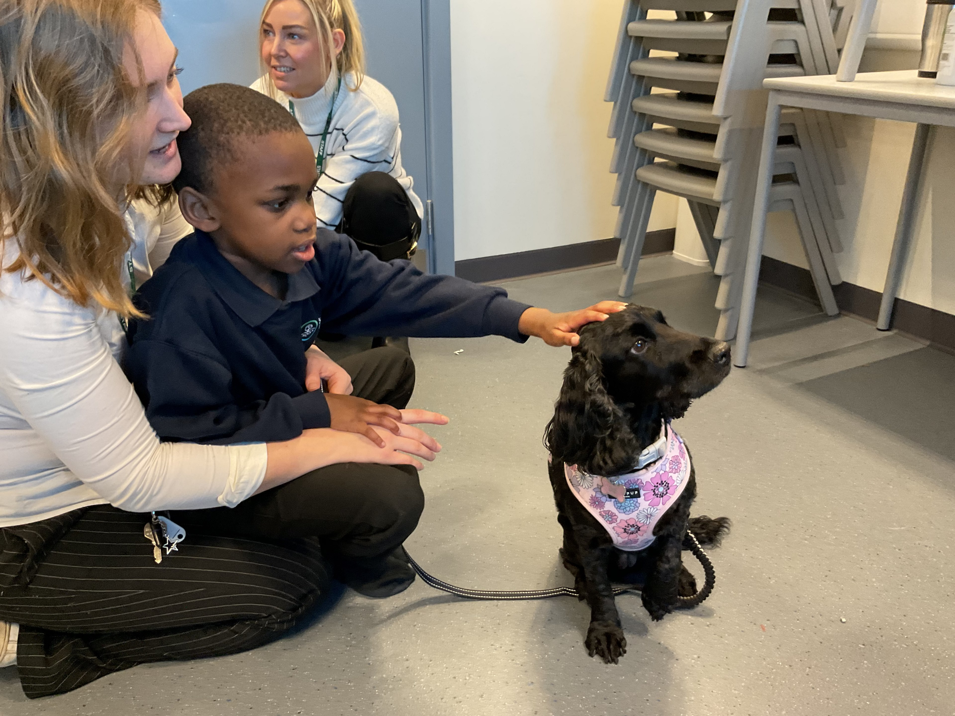

Coffee Morning
- April 11th – coffee morning 9am , behaviour INSPIRE approach with Diallo.
- We are rescheduling David from Disability Stockport 's talk to May 12th 1pm - you are welcome to attend and bring family or friends. David will present on life with autism as an adult as well as share a VR and video experience of the sensory experiences people with autism may experience.

Chinese New Year
Pupils enjoyed learning about Chinese New Year. Thank you to Chef Luke for making a delicious Chinese meal to celebrate this and for pupils who decorated the hall. Pupils loved their fortune cookies and we even had Chinese dragons made by a class who paraded around school.

Red Nose Day
We will be celebrating Red Nose Day on FRIDAY 21ST MARCH 2025 Brinksway School will provide pupils with a Red Nose and invite pupils to come in wearing red. If you would like to donate, please use this link Donate | Comic Relief to donate.

Easter Competition
We are inviting families into school to come and bake and craft with pupils on Friday April 11th. We will host a coffee morning from 9am where our Pastoral Lead (Diallo Pringle) will share our INSPIRE behaviour approach. We will also have a Easter craft and bake session for parents to attend from 10 - 11:00 following this. Please RSVP to the office 0161 260 5376



Holidays Dates

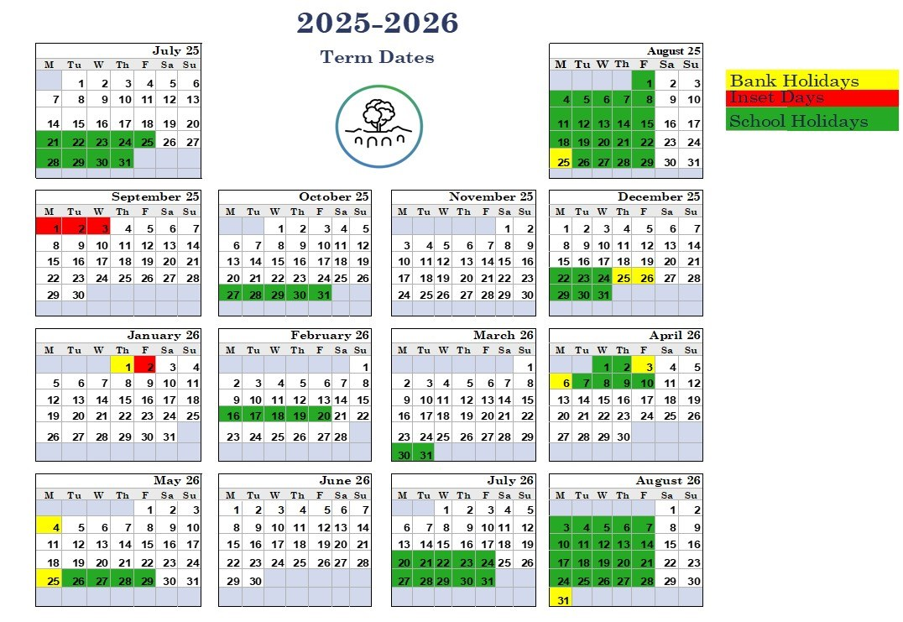
Please see our upcoming holiday dates for the academic year 2025- 2026. We request that holidays are booked out of term time for the coming year.

