Attendance Policy



 | Approved by: |  | Carla Adams-McCoy |  | Date: September 2024
 | Last reviewed on: |  | September 2024
 | Next review due by: |  | September 2025

Contents

1. Aims 2

2. Legislation and guidance 3

3. Roles and responsibilities 3

4. Recording attendance 6

5. Authorised and unauthorised absence 8

6. Strategies for promoting attendance 10

7. Attendance monitoring 10

8. Monitoring arrangements 11

9. Links with other policies 11

Appendix 1: attendance codes 12

1. Aims
We are committed to meeting our obligation with regards to school attendance through our whole-school culture and ethos that values good attendance, including:

Promoting good attendance
Reducing absence, including persistent and severe absence

Ensuring every pupil has access to the full-time education to which they are entitled

Acting early to address patterns of absence

Building strong relationships with families to ensure pupils have the support in place to attend school

We will also promote and support punctuality in attending lessons.

2. Legislation and guidance

This policy meets the requirements of the working together to improve school attendance from the Department for Education (DfE), and refers to the DfE’s statutory guidance on school attendance parental responsibility measures. These documents are drawn from the following legislation setting out the legal powers and duties that govern school attendance:

Part 6 of The Education Act 1996

Part 3 of The Education Act 2002

Part 7 of The Education and Inspections Act 2006

The Education (Pupil Registration) (England) Regulations 2006 (and 2010, 2011, 2013, 2016 amendments)

The Education (Penalty Notices) (England) (Amendment) Regulations 2013

This policy also refers to the DfE’s guidance on the school census, which explains the persistent absence threshold.

3. Roles and responsibilities
3.1 The governing board

The governing board is responsible for:

Promoting the importance of school attendance across the school’s policies and ethos

Making sure school leaders fulfil expectations and statutory duties

Regularly reviewing and challenging attendance data

Monitoring attendance figures for the whole school

Making sure staff receive adequate training on attendance

Holding the headteacher to account for the implementation of this policy

3.2 The headteacher

The headteacher is responsible for:

Implementation of this policy at the school

Monitoring school-level absence data and reporting it to governors.

Supporting staff with monitoring the attendance of individual pupils

Monitoring the impact of any implemented attendance strategies

Issuing fixed-penalty notices, where necessary

3.3 The designated Attendance Officer responsible for attendance

The designated senior leader is responsible for:

Leading attendance across the school

Offering a clear vision for attendance improvement

Evaluating and monitoring expectations and processes

Monitoring and keeping an oversight of data analysis

Devising specific strategies to address areas of poor attendance identified through data

Arranging calls and meetings with parents to discuss attendance issues

Delivering targeted intervention and support to pupils and families

Providing regular attendance reports to school staff and reporting concerns about attendance to the designated senior leader responsible for attendance and the headteacher

Benchmarking attendance data to identify areas of focus for improvement Working with education welfare officers to tackle persistent absence

The designated Attendance Officer responsible for attendance is Diallo Pringle and can be contacted on Diallo.Pringle@brinkswayschool.co.uk or 0161 260 5376.

3.4 Class Teachers
Class teachers are responsible for recording attendance on a daily basis, using the correct codes, and submitting this information to the school office each morning before 09:15am. In the event of teacher absence, this responsibility to record and submit the correct codes will fall to the TA/Cover Supervisor.

3.5 Admin staff
School admin staff will:
Take calls from parents about absence on a day-to-day basis and swiftly pass this information to the attendance officer.

Transfer calls from parents to the attendance officer in order to provide them with more detailed support on attendance.

3.6 Parents/carers
Parents/carers are expected to:
Make sure their child attends every day, on time.
Contact the school pupilabsence@brinkswayschool.co.uk
0161 260 5376 to report their child’s absence before 08:30am on the day of the absence (and each subsequent day of absence), and advise when they are expected to return.

- Provide the school with more than 1 emergency contact number for their child.
- Ensure that, where possible, appointments for their child are made outside of the school day.
- Parents will understand that the attendance officer may ask for confirmation of medical appointments

3.7 Pupils
Pupils are expected to:

Attend school every day on time

Attend every timetabled session on time

4. Recording attendance
4.1 Attendance register

We will keep an attendance register and place all pupils onto this register.
We will take our attendance register at the start of the first session of each school day and once during the second session. It will mark whether every pupil is:

Present

Attending an approved off-site educational activity

Absent

Unable to attend due to exceptional circumstances

Any amendment to the attendance register will include:

The original entry

The amended entry

The reason for the amendment

The date on which the amendment was made

The name and position of the person who made the amendment.

See appendix 1 for the DfE attendance codes.

We will also record:

Whether the absence is authorised or not

The nature of the activity if a pupil is attending an approved educational activity.

The nature of circumstances where a pupil is unable to attend due to exceptional circumstances.

We will keep every entry on the attendance register for 3 years after the date on which the entry was made.

Pupils must arrive in school by 08:50am on each school day.

The register for the first session will be taken at 09:00am and will be kept open until 09:15am.

4.2 Unplanned absence
The pupil’s parent/carer must notify the school of the reason for the absence on the first day of an unplanned absence by 08:30am or as soon as practically possible by calling the attendance officer (0161 260 5367) (see also section 7).

Where unplanned pupil absence occurs, parents/carers are required to notify the school via email or telephone on pupilabsence@brinkswayschool.co.uk OR 0161 260 5367

We will mark absence due to illness as authorised unless the school has a genuine concern about the authenticity of the illness.

If the authenticity of the illness is in doubt, the school may ask the pupil’s parent/carer to provide medical evidence, such as a doctor’s note, prescription, appointment card or other appropriate form of evidence. We will not ask for medical evidence unnecessary.

If the school is not satisfied about the authenticity of the illness, the absence will be recorded as unauthorised and parents/carers will be notified of this in advance.

4.3 Planned absence
Attending a medical or dental appointment will be counted as authorised as long as the pupil’s parent/carer notifies the school in advance of the appointment.

For planned absences, please contact the school’s attendance officer, Diallo Pringle – Diallo.pringle@brinkswayschool.co.uk or 0161 260 5367

However, we encourage parents/carers to make medical and dental appointments out of school hours where possible. Where this is not possible, the pupil should be out of school for the minimum amount of time necessary.

The pupil’s parent/carer must also apply for other types of term-time absence as far in advance as possible of the requested absence.

4.4 Lateness and punctuality

A pupil who arrives late:

- Before the register has closed will be marked as late, using the appropriate L code
- After the register has closed will be marked as absent, using the appropriate U code

Where ongoing punctuality issues/persistent lateness occurs, parent/carers will be contacted by the attendance officer for a discussion as to the barriers to punctuality.

4.5 Following up unexplained absence
Where any pupil we expect to attend school does not attend, or stops attending, without reason, the school will:

Call and/or text the pupil’s parent/carer on the morning of the first day of unexplained absence to ascertain the reason. Where the school does not receive a response, the emergency contact will be contacted. If the school cannot reach any of the pupil’s emergency contacts, the school may:
Carry out an unannounced home visit.
Make external enquiries/ referrals where necessary
Identify whether the absence is approved or not
Identify the correct attendance code to use and input it as soon as the reason for absence is ascertained – this will be no later than 5 working days after the session Call the parent/carer on each day that the absence continues without explanation to ensure proper safeguarding action is taken where necessary. If absence continues, the school will consider involving an education welfare officer.

4.6 Reporting to parents/carers
The school will regularly inform parents about their child’s attendance, attendance reports will be included in the child’s report and/or EHCP review.

5. Authorised and unauthorised absence
5.1 Approval for term-time absence

The headteacher will only grant a leave of absence to a pupil during term time if they consider there to

be 'exceptional circumstances'. A leave of absence is granted at the headteacher’s discretion, including the length of time the pupil is authorised to be absent for.

We define ‘exceptional circumstances’ as one-off family events (weddings/funerals/graduations etc), unavoidable medical appointments, social care meetings etc.

The school considers each application for term-time absence individually, taking into account the specific facts, circumstances and relevant context behind the request.

Any request should be submitted as soon as it is anticipated and, where possible, at least two weeks before the absence, and must be submitted in writing via an email to kaiya.garside@reddishhallschool.co.uk. The headteacher may require evidence to support any request for leave of absence.

Valid reasons for authorised absence include:

Illness and medical/dental appointments (see sections 4.2 and 4.3 for more detail)

Religious observance – where the day is exclusively set apart for religious observance by the religious body to which the pupil’s parents belong. If necessary, the school will seek advice from the parents’ religious body to confirm whether the day is set apart.
Traveller pupils travelling for occupational purposes – this covers Roma, English and Welsh gypsies, Irish and Scottish travellers, showmen (fairground people) and circus people, bargees (occupational boat dwellers) and new travellers. Absence may be authorised only when a traveller family is known to be travelling for occupational purposes and has agreed this with the school, but it is not known whether the pupil is attending educational provision.

5.2 Legal sanctions
The school or local authority can fine parents for the unauthorised absence of their child from school, where the child is of compulsory school age.

If issued with a fine, or penalty notice, each parent must pay £60 within 21 days or £120 within 28 days. The payment must be made directly to the local authority.

Penalty notices can be issued by a headteacher, local authority officer or the police.

The decision on whether or not to issue a penalty notice may take into account:

The number of unauthorised absences occurring within a rolling academic year One-off instances of irregular attendance, such as holidays taken in term time without permission
Where an excluded pupil is found in a public place during school hours without a justifiable reason

If the payment has not been made after 28 days, the local authority can decide whether to prosecute or withdraw the notice.

6. Strategies for promoting attendance
Brinksway School will promote good attendance (90% or above) with the following:

  - Certificates and chosen activities to celebrate 95%+ attendance

- Attendance monitoring

The attendance officer will regularly monitor students’ attendance by utilising a weekly tracking system. Attendance will be categorized into a weekly percentage, a half termly percentage, a termly percentage and a year-to-date percentage. These percentages will be colour coded to easily identify students whose attendance score is declining. Parents/carers may request to see a copy of their child’s attendance tracker, along with their attendance report.

7.1 Monitoring attendance
Brinksway School will:

Monitor attendance and absence data weekly, half-termly, termly and yearly across the school and at an individual pupil level.

Identify whether there are particular groups of children whose absences may be a cause for concern.

7.2 Analysing attendance
Brinksway School will:

Analyse attendance and absence data regularly to identify pupils or cohorts that need additional support with their attendance and use this analysis to provide targeted support to these pupils and their families.

Look at historic and emerging patterns of attendance and absence, and then develop strategies to address these patterns.

7.3 Using data to improve attendance
Brinksway School will:

Provide regular attendance reports to class teachers, and other school leaders, to facilitate discussions with pupils and families

Use data to monitor and evaluate the impact of any interventions put in place in order to modify them and inform future strategies

7.4 Reducing persistent and severe absence
Persistent absence is where a pupil misses 10% or more of school, and severe absence is where a pupil misses 50% or more of school.

The school will:
Use attendance data to find patterns and trends of persistent and severe absence

Hold regular meetings with the parents/carers of pupils who the school considers to be vulnerable, or are persistently or severely absent, to discuss attendance and engagement at school

Provide access to wider support services to remove the barriers to attendance

Make regular contact with parents/carers by way of letter(s), text messages, phone calls, emails and home visits, offering support where appropriate and necessary. Support packages will be reviewed at regular intervals to ensure their effectiveness.

8. Monitoring arrangements

This policy will be reviewed regularly, as a minimum 12 months by Diallo Pringle, Attendance Officer. At every review, the policy will be approved by a governor OR Regional Director OR Executive Headteacher

9. Links with other policies

This policy links to the following policies:

Child protection and safeguarding policy

- Behaviour policy

Appendix 1: attendance codes
The following codes are taken from the DfE’s guidance on school attendance.
 |  |  | Code |  |  | Definition |  |  | Scenario
 |  | / |  |  |  | Present (am) |  |  | Pupil is present at morning registration
 |  | \ |  |  |  | Present (pm) |  |  | Pupil is present at afternoon registration
 |  |  | L |  |  | Late arrival |  |  | Pupil arrives late before register has closed
 |  |  | B |  |  | Off-site educational activity |  |  | Pupil is at a supervised off-site educational
 |  |  |  |  |  |  |  |  | activity approved by the school
 |  |  | D |  |  | Dual registered |  |  | Pupil is attending a session at another setting
 |  |  |  |  |  |  |  |  | where they are also registered
 |  |  | J |  |  | Interview |  |  | Pupil has an interview with a prospective
 |  |  |  |  |  |  |  |  | employer/educational establishment
 |  |  | P |  |  | Sporting activity |  |  | Pupil is participating in a supervised sporting
 |  |  |  |  |  |  |  |  | activity approved by the school
 | V |  |  |  | Educational trip or visit |  |  | Pupil is on an educational visit/trip organised, or
 |  |  |  |  |  |  |  | approved, by the school
 | W |  |  |  | Work experience |  |  | Pupil is on a work experience placement

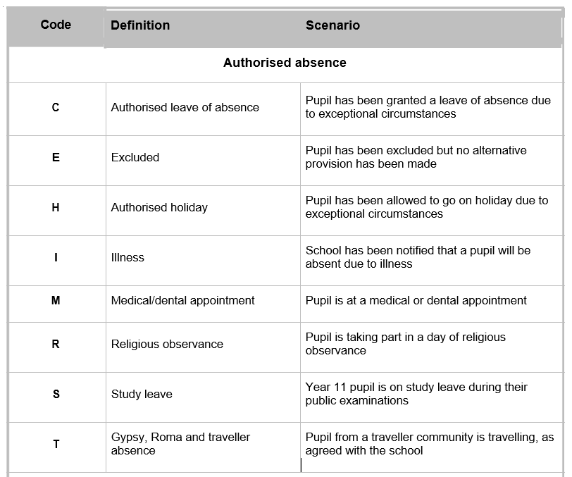

Unauthorised absence
Unauthorised Absence

Code | Definition | Scenerio
